**A COMPREHENSIVE REVIEW OF**

**NANOMATERIAL APPLICATION IN**

**OIL RECOVERY**

Project dissertation submitted in partial fulfilment

of the requirements for the award of

**BACHELOR OF TECHNOLOGY**

**IN PETROLEUM TECHNOLOGY**

*Submitted by*

***SREEVISHNU.K 18A91A2735***

***REUBEN P CHACKO 18A91A2733***

***BANDARU REVANTH 18A91A2708***

***ANANTHAKRISHNAN. V 18A91A2705***

**

**ADITYA ENGINEERING COLLEGE(A)**

**ADB ROAD, SURAMPALEM**

**KAKINADA, ANDHRA PRADESH-533437**

**MAY 2022**

*A COMPREHENSIVE REVIEW OF NANO FLUID APPLICATION IN OIL RECOVERY*



**DECLARATION**

We hereby declare that the work incorporated in this project entitled “**A Comprehensive Review Of Nanomaterial Application In Oil Recovery**” is original and carried out by us for the period from 1st March, 2022 to10th April, 2022. It has not been submitted in part or in full for any Degree of any other University.

***SREEVISHNU.K REUBEN P CHACKO***

***BANDARU REVANTH ANANTHAKRISHNAN. V***



i

*A COMPREHENSIVE REVIEW OF NANO FLUID APPLICATION IN OIL RECOVERY*



**CERTIFICATE**

This is to certify that it is a bonafide work done by **Mr Sreevishnu. K, Ms Ananthakrishnan. V, Ms Bandaru Revanth, Ms Reuben P Chacko** during the year 2022 in partial fulfilment of the requirements for theaward of degree of Bachelor of Technology in Petroleum Technology, Aditya Engineering College(A). This work is not submitted to any University for the award of any Degree/ Diploma.

Date:

Place:

|  |
| --- |
| *Guide* |
| **Prof. Kantimahanti Gargeryi** |
| Dept. of Petroleum Technology |
| Aditya Engineering College(A)  Surampalem |



ii

*A COMPREHENSIVE REVIEW OF NANO FLUID APPLICATION IN OIL RECOVERY*



**ACKNOWLEDGEMENT**

It would not have been possible without the kind support of many individuals in the course of completion of this project. We would like to extend our sincere thanks to all of them.

We would like to convey gratitude to our project guide ***Ms Kantimahanti Gargeyi,*** Asst. Professor, Dept. of Petroleum Technology, Aditya Engineering College (A) for providing us with this wonderful opportunity to complete our project report.

Our sincere gratitude to our Head of the Department, Dr ***R Giriprasad***, for guiding us at every stage of this project.

We are grateful to ***Mr VV Srimannarayana,*** for their continuous support at every stageduring this project work.

Special thanks to ***Dr T Anil Kumar***, Asst. Professor for his guidance throughout our course and thankful to all visiting faculties ***Mr YRC Sai Narayana, Mr***

for their efforts and encouragement at all stages of my course.

We are thankful to all teaching and non-teaching staff of Aditya Engineering College(A) and our family members who supported for completing this final project.

***SREEVISHNU.K REUBEN P CHACKO***

***BANDARU REVANTH ANANTHAKRISHNAN. V***



iii

*A COMPREHENSIVE REVIEW OF NANO FLUID APPLICATION IN OIL RECOVERY*



***CONTENTS***

|  |  |  |  |
| --- | --- | --- | --- |
|  |  |  | ***Page .No*** |
| ***CHAPTER-1*** | |  |  |
| **1. Introduction** | |  | **2** |
| 1.1 | Oil recovery in brief | | 2 |
| 1.2 | Types of oil recovery | | 4 |
| 1.3 | Factors affecting oil recovery | |  |
| 1.3 | Nanomaterial | | 6 |
| 1.4 | Common applications of Nano materials | | 6 |
| ***CHAPTER-2*** | |  |  |
| **2. Nanomaterial** | | | **10** |
| **2.1** | **Types of Nano materials** | | **10** |
|  | 2.1.1 | Nanoparticles | 11 |
|  | 2.1.2 | Nano clays | 14 |
|  | 2.1.3 | Nano emulsions | 17 |
| **2.2** | **Gas well testing** | | **21** |
| **2.3** | **Basic gas laws** | | **23** |
| **2.4** | **Gas reservoir fluid properties** | | **23** |
| **2.5** | **Deliverability test** | | **25** |
|  | 2.5.1 | Flow after flow test | 26 |
|  | 2.5.2 | Isochronal test | 26 |
|  | 2.5.3 | Modified isochronal test | 27 |
| ***CHAPTER-3*** | |  |  |
| **3. Well Test Planning** | | | **29** |
| 3.1 | Well testing data acquisition | | 29 |
| 3.2 | Well testing objectives | | 30 |
| 3.3 | Information obtained from well testing | | 30 |
| 3.4 | Methodology | | 30 |



iv

*A COMPREHENSIVE REVIEW OF NANO FLUID APPLICATION IN OIL RECOVERY*



|  |  |  |  |
| --- | --- | --- | --- |
| ***CHAPTER-4*** | |  |  |
| **4. Analysis and discussion** | | | **33** |
| 4.1 | **Case Study-1:** Estimation of Bg and Eg values | | 33 |
|  | 4.1.1 | Input data | 33 |
|  | 4.1.2 | Estimation | 35 |
| 4.2 | **Case Study-2:** Estimation of well bore storage coefficient (Cs) | | 38 |
|  | 4.2.1 | Input data | 38 |
|  | 4.2.2 | Estimation | 39 |
| 4.3 | **Case Study-3:** Pressure drawdown test | | 41 |
|  | 4.3.1 | Input data | 41 |
|  | 4.3.2 | Analysis | 42 |
| 4.4 | **Case Study-4:** Pressure buildup test | | 44 |
|  | 4.4.1 | Input data | 45 |
|  | 4.4.2 | Analysis | 45 |
| 4.5 | **Case Study-5:** Estimation of gas well deliverability | | 49 |
|  | 4.5.1 | Input data | 49 |
|  | 4.5.2 | Analysis | 50 |
| ***CHAPTER-5*** | |  |  |
| **5. Results summary** | | | **55** |

|  |  |
| --- | --- |
| ***REFERENCES*** | ***57*** |
| ***NOMENCLATURE*** | ***58*** |



v

*A COMPREHENSIVE REVIEW OF NANO FLUID APPLICATION IN OIL RECOVERY*



***List of figures***

|  |  |
| --- | --- |
|  | ***Page No.*** |
| **Figure-1:** Radius of investigation | 5 |
| **Figure-2:** Pressure vs time plot for flow patterns | 7 |
| **Figure-3:** Pressure vs time plot for flow regimes | 8 |
| **Figure-4:** Drawdown test-well bore pressure vs time plot | 12 |
| **Figure-5:** Drawdown test –flow rate vs time plot | 13 |
| **Figure-6:** Drawdown test-flowing bottom hole pressure vs time plot | 13 |
| **Figure-7:** Build up test, pressure vs time plot | 15 |
| **Figure-8:** Build up test, flow rate vs time plot | 16 |
| **Figure-9:** Injection / Fall off test | 18 |
| **Figure-10:** Drill Stem Test (DST) tool: open hole DST, cased hole DST | 19 |
| **Figure-11:** Interference test: pressure change and derivative vs elapsed time | 20 |
| **Figure-12:** Interference test, pressure vs time plot | 21 |
| **Figure-13:** Pseudo pressure | 22 |
| **Figure-14:** Pseudo time | 22 |
| **Figure-15:** Flow after flow, pressure vs time plot | 26 |
| **Figure-16:** Flow after flow, flow rate vs time plot | 26 |
| **Figure-17:** Modified isochronal test | 27 |
| **Figure-18:** Methodology:-work flow for execution of well testing | 31 |
| **Figure-19:** Z-factor and viscosity vs pressure plot | 35 |
| **Figure-20:** Z-factor vs pressure plot | 36 |
| **Figure-21:** Bg and Eg vs p plot | 37 |
| **Figure-22:** Bg and Eg vs p plot | 37 |
| **Figure-23:** Fluid filled wellbore | 39 |
| **Figure-24:** Rising liquid/gas interface | 39 |
| **Figure-25:** Pressure vs production time | 42 |
| **Figure-26:** Drawdown +build up: pressure vs time plot | 46 |
| **Figure-27:** Semi log plot: pressure vs (tp+Δt/Δt) | 46 |
| **Figure-28:** Pressure vs time plot | 50 |
| **Figure-29:** Flow rate vs time plot | 51 |
| **Figure-30:** P²-Pwf²/qg versus qg plot | 53 |



vi

*A COMPREHENSIVE REVIEW OF NANO FLUID APPLICATION IN OIL RECOVERY*



***List of Tables***

|  |  |
| --- | --- |
|  | ***Page No.*** |
| **Table-1:** Input data of Z-factor, Bg and Eg values | 34 |
| **Table-2:** Flow rate and flowing bottom hole pressure | 49 |
| **Table-3:** Δp² and log (Δp²) values | 51 |
| **Table-4:** n, C and AOF values | 52 |
| **Table-5:** a, b and AOF values | 52 |



vii

*A COMPREHENSIVE REVIEW OF NANO FLUID APPLICATION IN OIL RECOVERY*



***CHAPTER-1:***

***INTRODUCTION***



1

*A COMPREHENSIVE REVIEW OF NANO FLUID APPLICATION IN OIL RECOVERY*



1. **Introduction**

In the contemporary world, a global economic issue is a decrease in the supply of oil and an increase in the oil price. As the conventional reserves started getting depleted, it led to the demand-supply mismatch. This oil crisis can be reduced by using advanced technologies and innovative solutions using cost-effective methods. One of the important solution developed during the previous decade include Enhanced Oil Recovery (EOR). Although it improved production, it still need updates to utilize the existing reserves in an economical way.

It is in this context a new type of materials called ‘Nanomaterial’ became accessible for the oil and gas industry. They are the matter on a nuclear, atomic and super molecular Nanoscale, which is about 1-100 nm. Their unique properties have ability to influence the properties of residual oil. In this connection, this paper is to look into the role of Nano-particles in oil recovery and their impact on residual oil properties.

New type of fluids usually called “smart fluids” has become more accessible for the oil and gas industry. The nano-fluids are created by the addition of nanoparticles to fluids for intensification and improvement of some properties at low volume concentrations of the dispersing medium. Then the main feature of nanofluids is that their properties greatly depend on the dimensions of nanoparticles that are their components.



2

*A COMPREHENSIVE REVIEW OF NANO FLUID APPLICATION IN OIL RECOVERY*



***Well testing during field development stage***: The reservoir model will be refines to support the field development plan and to advise for the optimal location for additional production wells to be drilled.

***Well testing during the production stage***: Well tests are aimed at monitoring reservoirs, collecting data for history matching- comparing actual production with predicted production from reservoir simulator. These tests are be carried out using a pressure gauge, placed against the formation at sampling depth and collect the data during buildup and drawdown.

Broadly the well test classified into two categories. They are:

***Productivity Test:***

Obtain and analyze representative samples of produced fluids Measure reservoir pressure and temperature

Determine inflow performance relationship and deliverability Evaluate completion efficiency

Characterize well damage

Evaluate work over or stimulation treatments

This test mostly used for development and production wells. It involves physical or empirical determination of only produced fluid flow versus bottom hole pressure drawdown. These methods are performed at all times i.e., during initial completion, producing life of the well, and after recompletion of work over job. They involve the measurement of bottom hole static and flowing pressures, as well as fluid rate produced to the surface.

***Descriptive Test:***

Evaluate reservoir parameters

Characterize reservoir heterogeneities Assess reservoir extent and geometry

Evaluate hydraulic communication between wells.



3

*A COMPREHENSIVE REVIEW OF NANO FLUID APPLICATION IN OIL RECOVERY*



This test is mostly used in exploration & appraisal wells and is carried out when it is needed to estimate the reservoir’s geometry.

***1.2*** Types of oil recovery

PRIMARY AND SECONDARY RECOVERY

* Primary oil recovery refers to the process of extracting oil either via the natural rise of hydrocarbons to the surface of the earth or via pump jacks and other artificial lift devices.

. Secondary oil recovery includes the injection of gas or water which will displace the oil, force it to move from its resting place and bring it to the surface.

. Primary oil recovery accounts for 10% to 30% OOIP.

. Secondary oil recovery accounts for 10% to 20% OOIP.

* The combined oil recovery by the primary and secondary oil recovery methods could make only 20% to 50%.

ENHANCED OIL RECOVERY

* After primary and secondary oil recovery, 50% to 80% of the in-place oil is still trapped in the reservoir. In order to recover this huge volume of oil, Enhanced oil recovery methods are used.
* Most commonly used EOR methods are chemical, miscible, thermal and surfactant flooding. These methods alter the properties of the trapped oil present in the reservoir and make them mobile.
* Any improvements made in this stage of oil recovery will result in increase in overall production.



4

*A COMPREHENSIVE REVIEW OF NANO FLUID APPLICATION IN OIL RECOVERY*



* Although EOR is an alternative method to recover additional oil there are some drawbacks which include the degradation of chemicals under reservoir conditions, large volume of chemicals and high cost.
* Thus, Nanotechnology is profoundly attractive but challenging in the petroleum industry to enhance oil recovery.
* We study the changes happening to the highly viscous oil which is trapped in the reservoir by the addition of nanomaterials.



*A COMPREHENSIVE REVIEW OF NANO FLUID APPLICATION IN OIL RECOVERY*



Cwb = compressibility of well bore fluid

***1.3*** ***Types of well testing***

There are mainly two types and further classified them as follows: (Discussed in detail in Chapter-2),

1. ***Pressure transient Analysis (PTA) test:***

Drawdown Test Build up Test

Injection Test/Fall off Test Drill stem Test

Interference test

1. ***Deliverability test: (In case of Gas)***

Flow after Flow test Isochronal test

Modified Isochronal test

***1.4*** ***Data Required in Well Testing***

***Core data & Logging data:*** to check homogeneity, dual porosity, Oil Water Contact (OWC), Gas Water Contact (GWC) etc.

***Geological model data:*** for structural interpretation, position of Oil Water Contact (OWC), Gas Oil Contact (GOC) & Gas Water Contact (GWC)

***Drive mechanisms data***: type of the natural source of energy

***PVT fluid properties data Well completion data***

***Off set Well test data :*** Tests conducted in the offset wells for the same reservoir

***Equipment:*** Pressure gauges & Testing tools



***1.5 Fluid Flow Patterns& Regimes***

At different times, fluid flows in the reservoir in different ways generally based on the shape and size of the reservoir. Flow behavior classification is studied in terms of



6

*A COMPREHENSIVE REVIEW OF NANO FLUID APPLICATION IN OIL RECOVERY*



pressure rate of change with respect to time. Three main Flow patterns will be described mainly. They are: 1. Steady state Flow 2. Pseudo steady state Flow and 3.Transient state flow.

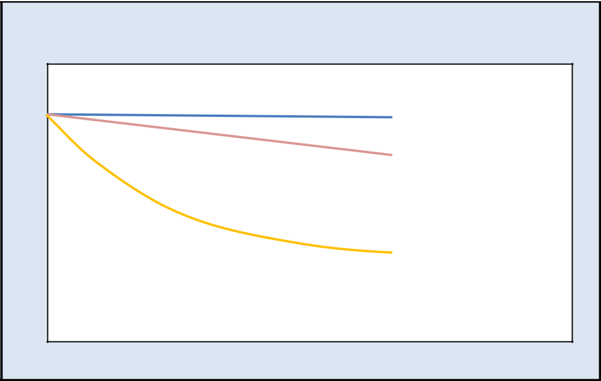

|  |  |  |
| --- | --- | --- |
|  | **Flow Patterns** |  |
|  | **Steady-State Flow** |  |
| **Pressure** | **Semisteady-State** |  |
|  |  |
|  | **Unsteady-State Flow** |  |
|  | **Time** |  |

**Figure-2**: Pressure vs Time Plot for Flow patterns

***Steady state flow:*** In steady state Flow, there is no pressure change anywhere with time. It occurs during the late time region when the reservoir has gas cap or aquifer support. This condition is also called constant pressure boundary where pressure maintenance might apply in the producing formation.

( ) = 0 ………………………………………………….Eq. (4)

***Pseudo steady state flow:*** This flow pattern occurs in late time region, but it forms when there is no flow in the reservoir outer boundaries. No flow boundaries can be caused by the effect of nearby producing or presence of sealing faults. It is a closed system or acts as a tank where a constant rate production results constant pressure drop for each unit of time. This flow is also called semi steady state or depletion state.

= …………………………………….….…..Eq. (5)



7

*A COMPREHENSIVE REVIEW OF NANO FLUID APPLICATION IN OIL RECOVERY*



***Transient state flow:*** When pressure/rate changes with time due to well geometry and the reservoir properties (permeability and heterogeneities), it indicates that transient flow occurs. It is observed before boundary effects are reached or also called infinite acting time period.

= ( )………………………………………………………… Eq. (6)

***Flow regimes:*** Flow of fluids in the reservoir is different at different time periods.

This is often a function of shape and size of the reservoir.

Early time region: wellbore storage linear(fracture)

bilinear spherical

Transient/Middle time region: Radial

Late time region: Transitional linear

stabilized(steady state) pseudo-steady state

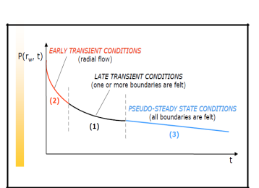

**Figure-3:** Pressure vs Time plot for flow regimes



8

*A COMPREHENSIVE REVIEW OF NANO FLUID APPLICATION IN OIL RECOVERY*



***CHAPTER-2:***

***TYPES OF WELL TESTING***



9

*A COMPREHENSIVE REVIEW OF NANO FLUID APPLICATION IN OIL RECOVERY*



1. **Types of Well Testing**

In general, well testing is classified into two main types. They are Pressure transient tests and Deliverability tests. Further they are sub-classified into several types and is used for specific cases and also based on the objective of the study to be carried out.

1. ***Pressure Transient Analysis (PTA) test:*** In which pressure is recorded as a function of time and interpreted using various analysis methods. Pressure-transient well-test analysis procedures are based on classical mathematical relationships between flow rate, pressure and time, which are directly analogous to the theory of heat transfer. PTA includes following tests,
   1. Drawdown Test
   2. Build up Test
   3. Injection Test/Fall off Test
   4. Drill stem Test
   5. Interference test
2. ***Deliverability test:*** In an oil or gas well to determine flow capacity at specific conditions of reservoir and flowing pressures. The absolute open flow potential (AOFP) can be obtained from these tests, and then the inflow performance relationship (IPR) can be generated. A deliverability test also is called a productivity test and it includes the following test,
   1. Flow after Flow test
   2. Isochronal test
   3. Modified Isochronal test

**2.1 Pressure transient analysis (PTA) test**

Transient pressure means the pressure response which results from a change in a well production rate. The rate change at the surface or sub-surface creates pressure diffusion (transient) in porous and permeable formations. The pressure diffuses away from the wellbore deep into formation and contains information about the properties and characteristics of the reservoir. This process is known as pressure transient well testing.



10

*A COMPREHENSIVE REVIEW OF NANO FLUID APPLICATION IN OIL RECOVERY*



***2.1.1 Drawdown Test***

Pressure drawdown tests can be defined as recording of bottom-hole pressure during flow at a constant producing rate. Generally, the well is shut in prior to the flow test.

In a drawdown test, a well, now static, stable, and shut-in, is open to flow. It is completed by producing the well at a constant flow rate while continuously recording bottom-hole pressure. Pressure gauge is lowered before opening the well. It may take a few hours to several days, depending on the objectives of test. Rate and pressure are recorded as a function of time.

The objectives of a drawdown test usually include estimation of permeability, skin factor, reservoir volume etc., These tests are particularly applicable to new wells, wells that have been shut-in sufficiently long to allow the pressure to stabilize, wells in which loss of revenue incurred in a buildup test.

***Equation for Drawdown test:*** Shut in the well till pressure reaches static level and then flow the well at a constant rate ‘q’ and measuring the ‘Pwf’**.**

Pwf =Pi – (162.6qµBo/kh)*(log t + log (k/ФµCtrw2)–3.23+0.87s)……..………. Eq. (7)

This is the equation of a straight line with slope

m = 162.6∗ ∗ ∗ 0 ……………………………………………………..

∗ℎ

From slope, permeability and skin can be calculated using the Eq. (9) & (10)

k=162.6∗ ∗ ∗ 0 ……………………………………………………..

∗ℎ

Calculate the Skin by using the Eq. (10),

Eq. (8)

Eq. (9)

1. = 1.151(((Pi– P1hr)/m) - log (k/ Ф.µ.Ct.,rw2 )+3.23)…………..……………. . Eq. (10) Where,

P1hr =flowing bottom hole pressure at 1 hour (psi)

Pi = initial pressure (psi)

q = flow rate (STB/day)



11

*A COMPREHENSIVE REVIEW OF NANO FLUID APPLICATION IN OIL RECOVERY*



µ = viscosity (Cp)

Bₒ = oil formation volume factor (bbl/STB)

k = permeability (mD)

Φ = porosity (%)

ct= total compressibility (psiˉ¹)

rw =well bore radius (ft)

S = skin factor

h = thickness of formation (ft)

m =slope (psi/ log-cycle)

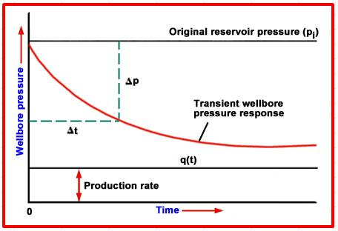

**Figure-4**: Drawdown test, Wellbore Pressure vs Time Plot



12

*A COMPREHENSIVE REVIEW OF NANO FLUID APPLICATION IN OIL RECOVERY*

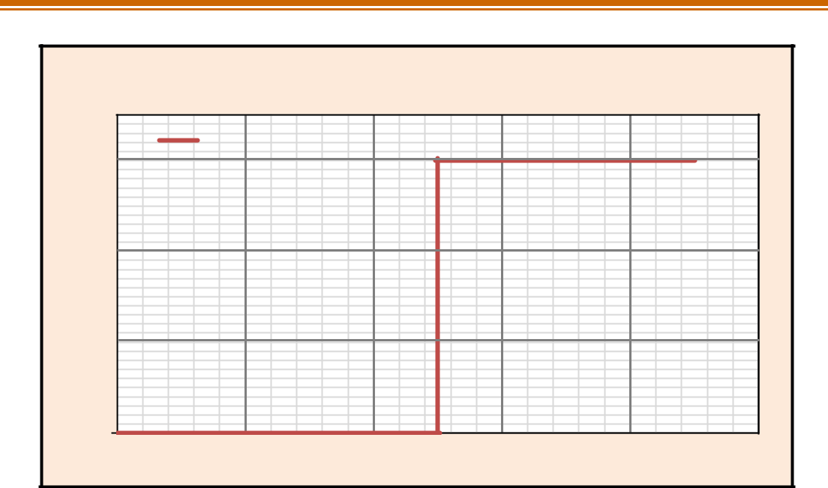

|  |
| --- |
| **Flow rate (q)** |

0

**Flow rate vs Time (Drawdown)**

flow rate

**Production**

**Shut-in**

**Time (tp)**

**Figure-5**: Drawdown test, Flow rate vs Time plot

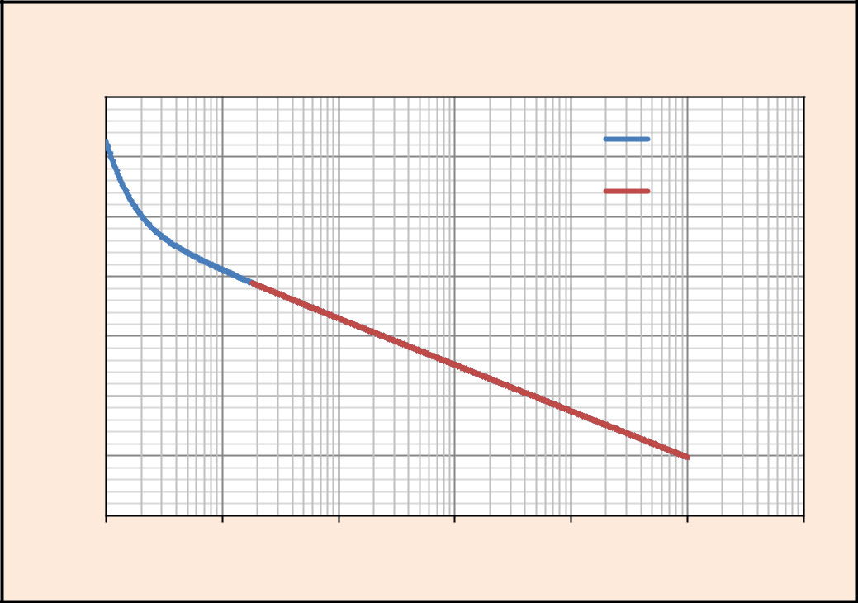

|  |
| --- |
| **Pressure(psia)** |

4980

4970

4960

4950

4940

4930

4920

4910

0.00

**Semi-Log Plot: Pressure Vs Production Time (Pressure Drawdown)**

Drawdown

Slope

0.01 0.10 1.00 10.00 100.00 1000.00

**Production Time (tp)**

**Figure-6:** Drawdown test, Flowing bottom hole pressure (BHP) vs Time plot



13

*A COMPREHENSIVE REVIEW OF NANO FLUID APPLICATION IN OIL RECOVERY*



***Advantages:***

– Drawdown tests are most suitable for new wells

– No loss of production

***Disadvantages:***

– Rate fluctuations are difficult to measure, especially on a continuous basis.

– Drawdown pressure data is erratic.

***2.1.2 Buildup Test***

In a buildup test, well producing at a constant rate is shut and the shut in bottom hole pressure is recorded. Well tests in exploration wells and new wells are often performed as drawdown-buildup sequence. In addition to providing data for reservoir characterization, such as permeability, skin, buildup tests can also provide data for reservoir monitoring, in particular reservoir pressure data.

Planned buildup tests have a cost in terms of lost production and this will limit the amount of available last time shut-in data. It is easier to get high quality data from buildup test than from drawdown test and the effect of wellbore storage is minimized using a down hole shut-in. However, production wells normally do not produce with 100% efficiency and in wells with permanent down hole pressure gauges, the periods of unplanned shut-in may provide well test data at no extra cost.

Equation for Pressure Buildup test,

Pi– Pws = (162.6*q*Bₒ*µₒ)/k*h[log(tp+Δt)/Δt]……………….……………. Eq. (11)

Where,

Pi= initial pressure (psi)

Pws=shut-in bottom hole pressure (psi)

q= flow rate (STB/day)

Bₒ= oil formation volume factor (Rbbl/STB)

µₒ=viscosity of oil (Cp)

k=permeability (mD)

h= thickness of formation (feet)



14

*A COMPREHENSIVE REVIEW OF NANO FLUID APPLICATION IN OIL RECOVERY*



tp= producing time (hours)

Δt =shut-in time (hours)

The Eq. (11) suggests that shut in BHP recorded during a pressure buildup test should plot as a straight line function of log (tp+Δt)/Δt

1. =162.6∗ ∗ ∗ ∗ℎ

The formation permeability can be determined by calculating slope ‘m’ of the straight line. If the straight line extrapolate to infinite shut-in time, it gives the extrapolated formation pressure P*(<=Pi).

The skin will be calculated by using available pressure build up data from the below equation.

S=1.151[(P1hr-Pwf)/m – log (k/ϕ*µ*ct*rw²) +3.23] …………………..………Eq. (12)

***Assumptions:***

The infinite reservoir assumption The single-phase liquid assumption

The homogenous reservoir assumption

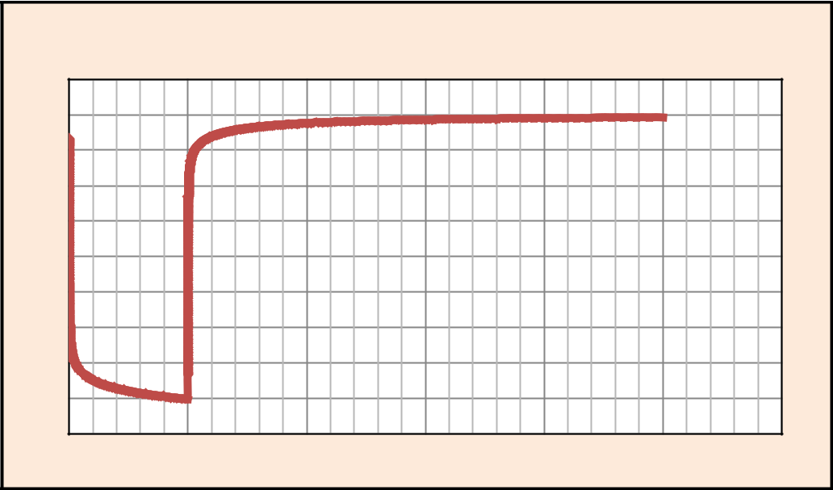

**Pressure vs Time plot**

|  |
| --- |
| **Pressure (psi)** |

Pi

ΔP BUP

ΔP DD

P(Δt=0)

**Time**

**Figure-7**: Buildup test, Pressure vs Time plot



15

*A COMPREHENSIVE REVIEW OF NANO FLUID APPLICATION IN OIL RECOVERY*

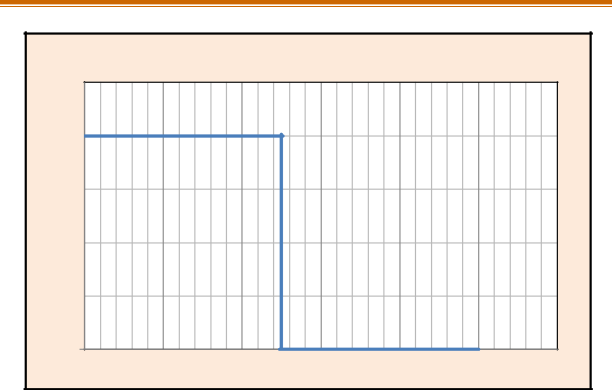

|  |
| --- |
| **Flow Rate** |

0

**Flow rate vs Time plot**

Drawdown

Buildup

**Time**

**Figure-8**: Buildup test, Flow rate vs Time plot

***Advantage:***

– Precise control of rate

– P*(<=Pi) can be determined in a buildup test

***Disadvantage:***

– During a buildup test there is a loss of production due to shut in.

***Methods of interpretation of the Pressure Buildup data plots:***

1. Horner's plot
2. Miller, Dyes and Hutchinson (MDH) method
3. Matthews– Brons - Hazebroek method
4. Muskat method
5. Extended Muskat method

***Horner's plot:*** The method of extrapolating the pressure build-up data for an infinite acting reservoir including principle of superposition was given by Horner. The Horner’s plot is useful in the estimation of extrapolated pressure. Presence of skin, faults, layers and reservoir boundary causes variation in shape of the build-up curve.



16

*A COMPREHENSIVE REVIEW OF NANO FLUID APPLICATION IN OIL RECOVERY*



Other factors like phase separation in tubing, interference due to other wells also have their characteristic impact on the linearity of the Horner's plot.

Pi-Pws= (162.6qµBo/kh) log (tp+∆t/∆t)…………..……..…………………… Eq. (13)

This is the equation of a straight line when plotted as Pws vs log (tp+∆t/∆t) and Horner’s plot with slope

m=162.6qµBo/kh and intercept Pi,

From this, k & s can be determined as

k =162.6(q µBo/mh) ………………………………...……………………… Eq. (14)

1. =1.1513(((P1hr-Pwf)/m)-log (k/Ф µCtrw2) +3.23) …….…..……………..….. Eq. (15)

∆P skin= 0.87*m*s ……………………………………………………….…Eq. (16)

***2.1.3 Injection / Fall of Test***

***Injection test:*** In an injection test, the well will shut in until the pressure stabilizes and then injection will begin at a constant rate while recording the bottom hole pressure.

***Fall off test:*** It is usually preceded by a long injection test. Pressure is recorded after injection is stopped. In some fall off tests, the pressure at the well head goes on vacuum.



17

*A COMPREHENSIVE REVIEW OF NANO FLUID APPLICATION IN OIL RECOVERY*

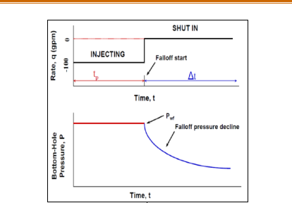

**Figure-9:** Injection/fall off test (Source: Sadiq J. Zarrouk)

***2.1.4 Drill Stem Test (DST)***

The testing of potential zones can be done during drilling and after drilling. The need to carry out the test is based on necessity in an exploratory area. There are 2 types of tests, they are Open hole drill stem test and Cased hole drill stem test.

***Open hole Drill Stem Test:*** Open hole drill stem test is carried out based on the initial indications of oil or gas while drilling and also positive indications of hydrocarbons in processed electro log data. It provides information of potential zones which are essential in evaluating the reservoir.

***Cased hole Drill Stem Test:*** After drilling and casing a well, a retrievable production packer is set above the zone of interest. The well is tested through the perforations in the casing. It is useful in the fields where a number of pay zones are encountered in the same well.



18

*A COMPREHENSIVE REVIEW OF NANO FLUID APPLICATION IN OIL RECOVERY*

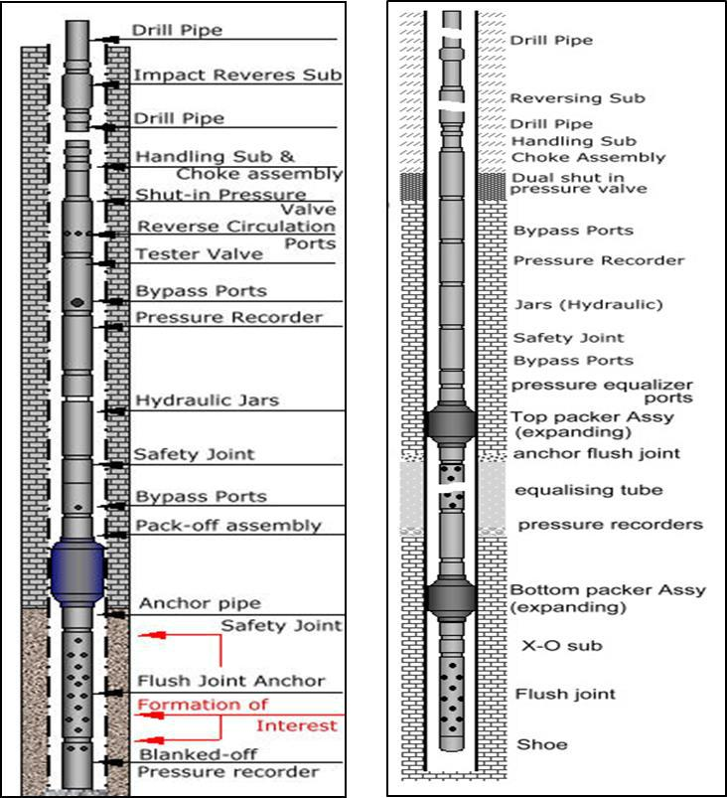

**Figure-10:** Drill Stem Test (DST) tool: Open hole DST (Left), Cased hole DST (Right)

The following information can be obtained from the open hole DST data,

1. Nature and type of fluids
2. Initial reservoir pressure
3. Flow rates
4. Extent of depletion with production
5. Indications of reservoir anomalies - Faults/ Barriers



19

*A COMPREHENSIVE REVIEW OF NANO FLUID APPLICATION IN OIL RECOVERY*



***2.1.5*** ***Interference Test***

In an interference test, a well is selected as an active well, and its production rate is changed to vary the pressure of the reservoir. At the same time, a neighboring well acts as an observation well, in which a high precision pressure gauge is used to record the pressure variation.

***Producing well:***

* Create signal at producing well
* Measure the signal at both wells

***Observation well:***

* The signal will be received with a delay
* The response is smaller

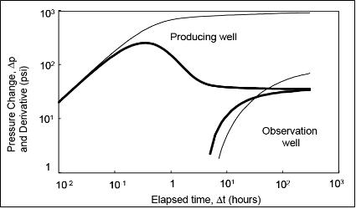

**Figure-11:** Interference test: Pressure change and Derivative vs Elapsed Time

(Source: Giuseppe Moricca)



20

*A COMPREHENSIVE REVIEW OF NANO FLUID APPLICATION IN OIL RECOVERY*

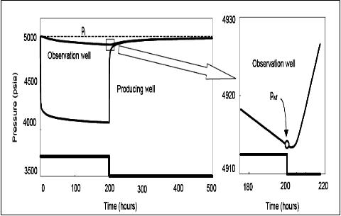

**Figure-12:** Interference test: Pressure vs Time (Source: Giuseppe Moricca)

**2.2 Gas well testing**

Gas well test analysis provides information derived from flow and pressure transient tests about in-situ reservoir conditions. Contrary to liquids, a gas is a highly compressible and less viscous in nature.

Depending on the values of reservoir pressure, viscosity and gas compressibility factor, the gas flow behavior can be treated as a function of either pressure to the second power or linear pressure with a region which does not correspond to any of these and it is better represented by a synthetic function called pseudo pressure.

***Pseudo pressure:*** A mathematical pressure function that accounts for variable compressibility and viscosity of gas with respect to pressure. It accounts for normalization of pressures as compressibility and viscosity are varying with pressure.



21

*A COMPREHENSIVE REVIEW OF NANO FLUID APPLICATION IN OIL RECOVERY*

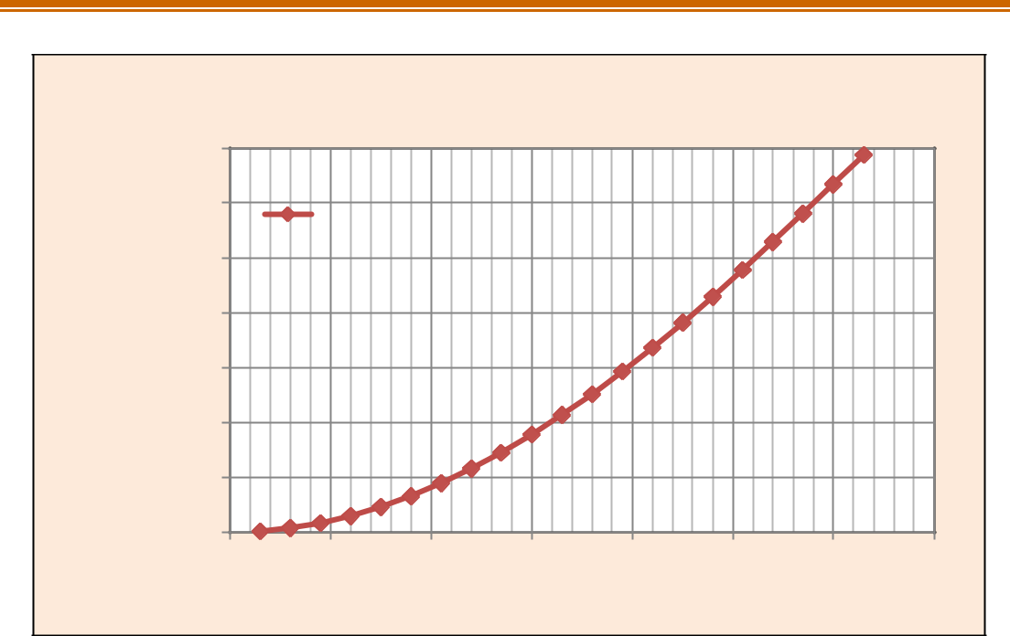

**Pseudo pressure**

|  |  |  |  |  |  |  |  |  |  |
| --- | --- | --- | --- | --- | --- | --- | --- | --- | --- |
|  | 700000000 |  |  |  |  |  |  |  |  |
|  | 600000000 | pseudo pressure | |  |  |  |  |  |  |
|  |  |  |  |  |  |  |  |
| **m(psia²/Cp)** | 500000000 |  |  |  |  |  |  |  |  |
| 400000000 |  |  |  |  |  |  |  |  |
| 300000000 |  |  |  |  |  |  |  |  |
|  |  |  |  |  |  |  |  |  |
|  | 200000000 |  |  |  |  |  |  |  |  |
|  | 100000000 |  |  |  |  |  |  |  |  |
|  | 0 |  |  |  |  |  |  |  |  |
|  | 0 | 500 | 1000 | 1500 | 2000 | 2500 | 3000 | 3500 |  |
|  |  |  |  | **Pressure(psia)** | |  |  |  |  |

**Figure-13:** Pseudo pressure

***Pseudo time:*** Another artificial function referred as pseudo time is included to further understand the transient behavior of gas flow in porous media.

Pseudo time is a mathematical time function that accounts for the variable total compressibility (Ct), viscosity (µg) of gas, with respect to time and pressure.

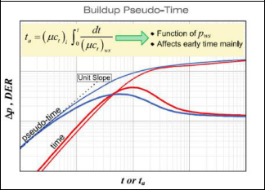

**Figure-14:** Pseudo time



22

*A COMPREHENSIVE REVIEW OF NANO FLUID APPLICATION IN OIL RECOVERY*



**2.3** **Basic gas laws**

***Boyle’s law:*** The volume of a given amount of gas held at constant temperature varies inversely with the applied pressure.

PV= Constant ………………………………………………… Eq. (24)

P1V1=P2V2……..……………………………….…………….. Eq. (25)

***Charles’ law:*** The volume of a given amount of gas held at constant pressure is directly proportional to the absolute temperature.

V/T= Constant ………………………………………………… Eq. (26)

V1/T1=V2/T2 …………………………………………………. Eq. (27)

***Ideal Gas law:*** A gas can be defined as a homogenous fluid of low density and low viscosity, which has neither independent shape nor volume. It expands to completely fill the vessel in which it is contained. The properties of gases differ from liquids mainly because the molecules in gases are much further apart than liquids. The ideal gas law is,

PV=nRT …………………………………………… Eq. (28)

Where,

P= Pressure

T=Temperature

V=Volume of gas

n=number of moles

R=universal gas constant (0.0821 L-atm/mole-k)

**2.4** **Gas reservoir fluid properties**

***Specific gravity:*** The ratio of apparent molecular weight of a gas to that of air is known as specific gravity of gas.

= = ……………………………………………………. Eq. (29)

28.97

Units: lb/ft³



23

*A COMPREHENSIVE REVIEW OF NANO FLUID APPLICATION IN OIL RECOVERY*



***Viscosity:*** The measure of internal fluid friction to the flow is known as viscosity.

|  |  |  |  |  |  |  |
| --- | --- | --- | --- | --- | --- | --- |
|  |  |  | Τ |  | |  |
|  | µ= |  | | | …………………………………………………………… Eq. (30) |  |
|  |  | | |  |
|  |  |  | | | |  |
| Units: cp |  |  | T= Shear Stress | | |  |
|  | = ℎ , = | | | | |  |

***Compressibility factor/Gas deviation factor:*** Compressibility factor (Z) value reflects how much the real gas deviates from ideal gas.

Z= Vₐ/Vᵢ ……………….…………………………………………. Eq. (31)

Where,

Va = Actual volume

Vi = Ideal volume

***Gas formation volume factor:*** The volume of gas at reservoir pressure and temperature to the volume of gas at standard conditions of pressure and temperature is known as gas formation volume factor.

Bg = 0.028∗ ∗ …………………………………………………… Eq. (32)

Units: ft³/SCF

Bg=0.005035∗ ∗ ……………………………………………………. Eq. (33)

Units: bbl/SCF

***Expansion factor:*** The ratio of volume of gas at standard conditions to the volume of gas at reservoir conditions is known as expansion factor.

g = ℬ 1……………………………………………………. Eq. (34)

Units: SCF/ft³

Eg = 198.6∗ ……………………………………………………. Eq. (35)

∗

Units: SCF/bbl

g = 35 ∗ .37∗  ……………………………………………………. Eq. (36)



24

*A COMPREHENSIVE REVIEW OF NANO FLUID APPLICATION IN OIL RECOVERY*



**2.5 Deliverability test**

The following test are carried out for the gas well to estimate the Absolute Open Flow (AOF) potential.

Flow after flow test Isochronal test

Modified Isochronal test

***2.5.1 Flow after Flow test***

Flow after flow test is conducted by producing the well in a series of stabilized flow rates in increasing order, measuring the flowing bottom hole pressure at the sand face and stabilized rate at surface.

Two fundamentally different techniques are used to analyze the test data. They are Empirical method and Theoretical method.

***Empirical method:*** An empirical observation with a rather tenuous theoretical basis, a plot of Δp²=**pr2-pwf²** vs **qg** on log-log paper is a straight line.

qg = C(pr²-pwf²)ⁿ ……………………..……………………………. Eq. (17)

To estimate the absolute open flow potential (AOFP), the theoretical rate at which the well would produce if the flowing bottom hole pressure Pwf were atmospheric, it may be necessary to extrapolate the curve beyond range of test data.

2− 1

n= log( 2− 2)2−log( 2− 2)1 ………………………………………. Eq. (18)

C = ( 2− 2)ⁿ …………………….…………………………………. Eq. (19)

***Theoretical method:*** The theoretical deliverability equation is,

(Pr²-Pwf²)/qg= a+bqg………………………………………………………. Eq. (20)



25

*A COMPREHENSIVE REVIEW OF NANO FLUID APPLICATION IN OIL RECOVERY*



A plot of (Pr²-Pwf²)/qg vs qg gives a straight line. By solving the a , b we can determine the points on the deliverability curves calculated from theoretical equation.

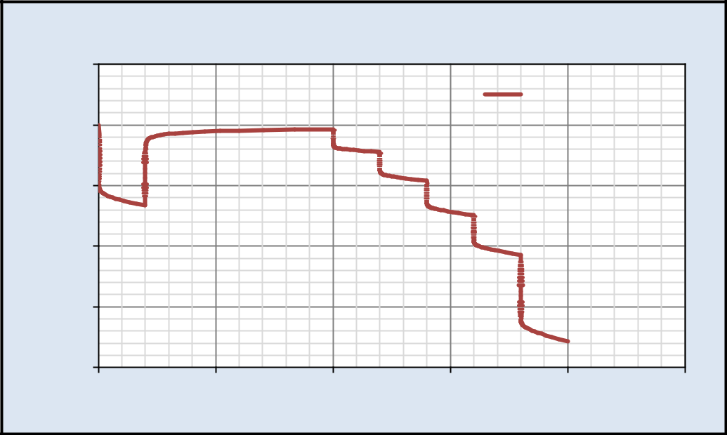

**Pressure vs Time plot**

|  |  |  |  |  |  |  |  |
| --- | --- | --- | --- | --- | --- | --- | --- |
|  | 5100 |  |  |  |  |  |  |
|  |  |  |  |  | Pressure (psia) |  |  |
|  | 5000 |  |  |  |  |  |  |
| **(psia)** | 4900 |  |  |  |  |  |  |
|  |  |  |  |  |  |  |
| **Pressure** | 4800 |  |  |  |  |  |  |
|  |  |  |  |  |  |  |
|  | 4700 |  |  |  |  |  |  |
|  | 4600 |  |  |  |  |  |  |
|  | 0 | 50 | 100 | 150 | 200 | 250 |  |

**Time (hours)**

**Figure-15:** Flow after Flow test: Pressure vs Time plot

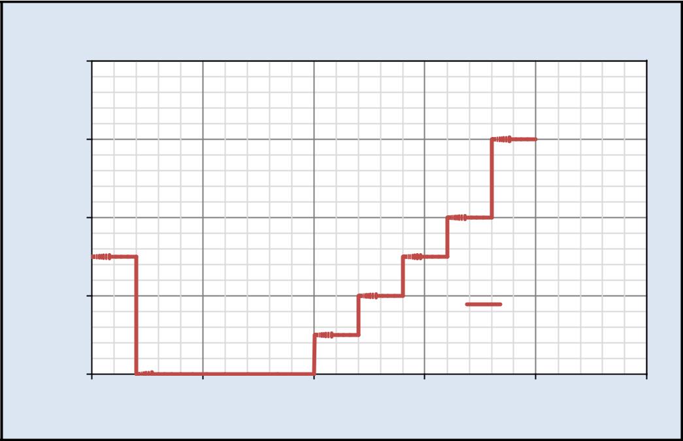

|  |
| --- |
| **Flow rate (MMscf/day)** |

16

12

8

4

0

0

**Flow rate vs Time plot**

Flow rate

(MMscf/day)

50 100 150 200 250

**Time (hours)**

**Figure-16:** Flow after Flow test: Flow rate vs Time plot

***2.5.2*** ***Isochronal test***



26

*A COMPREHENSIVE REVIEW OF NANO FLUID APPLICATION IN OIL RECOVERY*



The objective of isochronal testing is to obtain data to establish stabilized deliverability curve for a gas well without flowing the well for sufficiently long intervals to achieve stabilized conditions. This procedure is generally for low permeability reservoirs. The well is flowed at a fixed rate, and shut in for the pressure to build up to a constant value. The well is then flowed at a second rate for the same amount of time. Followed by another shut in etc.,

(Pr²-Pwf²)/qg = a+bqg …………………………………………… Eq. (21)

(Pr²-Pwf²)=aqg+bqg² …………………………………………….. Eq. (22)

The constants, a & b can be determined from Eq. (23)

|  |  |  |  |  |
| --- | --- | --- | --- | --- |
|  | √ 2+4 ( 2 | −(14.72)) | |  |
| AOF =− + |  |  | …………………………………. Eq. (23) |  |
| 2 |  |  |
|  |  |  |  |
| **2.5.3 *Modified isochronal test*** | |  |  |  |

The objective of modified isochronal tests is to obtain the same data as in an isochronal test without using the lengthy shut-in periods for pressure stabilization before each flow test is run. In this test, shut-in periods are of the same duration as the flow periods are used. Modified isochronal tests are widely used as they conserve time and money and have proved to be excellent approximations to true isochronal tests.

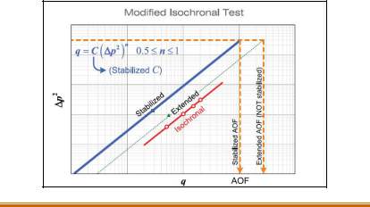

27

*A COMPREHENSIVE REVIEW OF NANO FLUID APPLICATION IN OIL RECOVERY*



**Figure-17:** Modified isochronal test

***CHAPTER -3:***

***WELL TEST PLANNING***



28

*A COMPREHENSIVE REVIEW OF NANO FLUID APPLICATION IN OIL RECOVERY*



1. **Well Test Planning**

Well testing is the process of capturing data from a live well over time to analyze and understand the well & reservoir behavior in real time. A well test acquires data on the hydrocarbon properties such as reservoir temperature, pressure, drainage area, GOR, WOR etc.

Well testing involves an array of measurements and multiple types of down hole instruments for gathering information on well characteristics. During a well test, a transient pressure response is created by a temporary change in production.

The following points need to be defined and kept ready while planning for Well Testing

* It includes

– Test type: Based on the purpose.Types of tests will be Drawdown, Buildup, DST, gas well testing (AOFP) and injection tests.

– Test duration: Based on the complexity and the risks involved in the planned test duration.

* Operational requirements

– well completion data

– location and pattern of wells

* Reservoir

– flow rates data of the reservoir fluids

– fluid type whether it is gas/ condensate/ oil/ water

* Pressure data

– Initial reservoir pressure(Pi), flowing bottom hole pressure(Pwf)

**3.1 Well testing - data acquisition**

Data acquisition involves gathering of raw data from various sources such as static and flowing pressure measurements, pressure transient tests, records of produced volume of fluids (oil, gas and water).



29

*A COMPREHENSIVE REVIEW OF NANO FLUID APPLICATION IN OIL RECOVERY*



Down Hole Pressure/Temperature Recorders: The data is acquired by pressure gauges.

Components of down hole equipment: Pressure Gauge

Power Source Memory unit

1 to 2 recorders are used while testing

Surface pressures are readout by wire line link

**3.2 Well testing objectives**

– ***Exploration well:*** In exploratory wells, confirm HC existence, predict a first production forecast (DST: fluid nature, Pi, reservoir properties)

– ***Appraisal well:*** Refine previous interpretation, PVT sampling, (longer test: production testing)

– ***Development well:*** On production well, satisfy need for well treatment, (interference testing, Pavg)

**3.3** **Information obtained from well testing**

***Well :***Production Index (PI), Flow Efficiency(FE) and Skin

***Reservoir:***

Average permeability (kavg)

Heterogeneities(fractures, layering) Boundaries (distance and “shape”) Pressure (initial and average)

**3.4 Methodology**

***The inverse problem:*** The type of response of the disturbed area are the characteristics of the reservoir properties, it is possible to infer reservoir properties from the response. Well test interpretation is therefore an inverse problem where model parameters are inferred by analyzing the model response to a given change.



30

*A COMPREHENSIVE REVIEW OF NANO FLUID APPLICATION IN OIL RECOVERY*

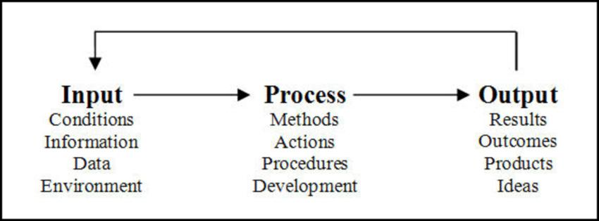

**Figure-18:** Methodology: Workflow for execution of Well testing

***Model recognition:*** Well test interpretation models are often different from the geological or log models. Interpretation models are made of several components, which are relatively independent, and exhibit different characteristics. Once all the components have been identified, the interpretation model is defined.

***Well test:*** Further, it is important to determine the ability of a formation to produce reservoir fluids and underlying reason for a well's productivity.

Well Test data when combined with hydrocarbon production data and the laboratory data on fluid and rock properties:

Afford the means to estimate the original hydrocarbon in-place

The recovery that may be expected from the reservoir under various modes of exploitation

In addition, well test data and IPR well performance equations, combined with production data, help to design, analyze, and optimize total well production system or production optimization**.**



31

*A COMPREHENSIVE REVIEW OF NANO FLUID APPLICATION IN OIL RECOVERY*



***CHAPTER – 4:***

***ANALYSIS & DISCUSSION***



32

*A COMPREHENSIVE REVIEW OF NANO FLUID APPLICATION IN OIL RECOVERY*



1. **Analysis & Discussion**

In this chapter, calculation of Gas parameters such as gas formation volume factor & expansion factor, estimation of well bore parameters like well bore storage coefficient, Gas well deliverability and analysis of data obtained from Drawdown & Buildup test have been carried out and outputs have been discussed in detail.

Each analysis has been explained under the heading of a case study.

***Case Study-1:***Estimation of Gas Formation Volume Factor (Bg) & Expansion Factor (Eg)

***Case Study-2:*** Estimation of Well Bore Storage Coefficient

***Case Study-3:*** Pressure Drawdown Test

***Case Study-4:*** Pressure Buildup Test

***Case Study-5:*** Estimation of Gas Well Deliverability

**4.1 Case Study-1: Estimation of Gas formation volume factor (Bg) & expansion factor (Eg)**

In this case study, a well with a reservoir temperature of 200ºF was considered. The pressures and corresponding viscosity and z-factor values were provided.

With the given data, ‘Bg’ and ‘Eg’ values were calculated at different pressure and z-factor values and plotted.

***4.1.1*** ***Input data***

Reservoir temperature Pressure (std. conditions) Temperature (std. conditions) Z – Factor

= 200ºF (660ºR)

= 14.7 psia

= 460ºR

= Values are given in the table 1



33

*A COMPREHENSIVE REVIEW OF NANO FLUID APPLICATION IN OIL RECOVERY*



**Table-1:** Input data of Z-Factor, Bg and Eg values

|  |  |  |  |  |  |  |  |
| --- | --- | --- | --- | --- | --- | --- | --- |
| **Pressure** | **Z-Factor** | **Viscosity** | **Bg** | **Bg** | **Eg** | **Eg** |  |
| **(bbl/scf)** | **(ft3/scf)** | **(scf/bbl)** | **(scf/ft3)** |  |
|  |  |  |  |
|  |  |  |  |  |  |  |  |
|  |  |  |  |  |  |  |  |
| 201 | 0.980 | 0.012 | 0.02 | 0.09 | 61.71 | 10.99 |  |
| 402 | 0.960 | 0.012 | 0.01 | 0.04 | 125.87 | 22.42 |  |
| 603 | 0.943 | 0.013 | 0.01 | 0.03 | 192.42 | 34.28 |  |
| 804 | 0.920 | 0.013 | 0.00 | 0.02 | 261.22 | 46.53 |  |
| 1005 | 0.910 | 0.013 | 0.00 | 0.02 | 332.02 | 59.15 |  |
| 1206 | 0.900 | 0.014 | 0.00 | 0.01 | 404.48 | 72.06 |  |
| 1407 | 0.890 | 0.014 | 0.00 | 0.01 | 478.12 | 85.18 |  |
| 1608 | 0.880 | 0.015 | 0.00 | 0.01 | 552.37 | 98.40 |  |
| 1809 | 0.870 | 0.015 | 0.00 | 0.01 | 626.50 | 111.63 |  |
| 2010 | 0.860 | 0.016 | 0.00 | 0.01 | 700.17 | 124.74 |  |
| 2211 | 0.863 | 0.016 | 0.00 | 0.01 | 772.47 | 137.62 |  |
| 2412 | 0,861 | 0.017 | 0.00 | 0.01 | 842.97 | 150.18 |  |
| 2613 | 0.862 | 0.018 | 0.00 | 0.01 | 911.23 | 162.43 |  |
| 2814 | 0.860 | 0.018 | 0.00 | 0.01 | 976.97 | 174.00 |  |
| 3015 | 0.870 | 0.019 | 0.00 | 0.01 | 1039.98 | 185.00 |  |
| 3216 | 0.870 | 0.020 | 0.00 | 0.01 | 1100.18 | 196.00 |  |
| 3417 | 0.880 | 0.020 | 0.00 | 0.00 | 1157.54 | 206.00 |  |
| 3618 | 0.890 | 0.020 | 0.00 | 0.00 | 1212.11 | 215.00 |  |
| 3819 | 0.900 | 0.021 | 0.00 | 0.00 | 1263.95 | 225.00 |  |
| 4020 | 0.920 | 0.022 | 0.00 | 0.00 | 1313.19 | 233.00 |  |
| 4221 | 0.930 | 0.023 | 0.00 | 0.00 | 1359.94 | 242.28 |  |
| 4422 | 0.940 | 0.024 | 0.00 | 0.00 | 1404.34 | 250.19 |  |
| 4623 | 0.961 | 0.024 | 0.00 | 0.00 | 1446.51 | 257.70 |  |
| 4823 | 0.970 | 0.025 | 0.00 | 0.00 | 1486.50 | 264.85 |  |
| 5024 | 0.990 | 0.025 | 0.00 | 0.00 | 1524.75 | 271.64 |  |
| 5225 | 1.000 | 0.027 | 0.00 | 0.00 | 1561.07 | 278.11 |  |
| 5426 | 1.020 | 0.027 | 0.00 | 0.00 | 1595.68 | 284.28 |  |
| 5627 | 1.030 | 0.028 | 0.00 | 0.00 | 1628.71 | 290.16 |  |
| 5828 | 1.050 | 0.028 | 0.00 | 0.00 | 1660.24 | 295.78 |  |
| 6029 | 1.070 | 0.029 | 0.00 | 0.00 | 1690.26 | 301.15 |  |
| 6230 | 1.090 | 0.029 | 0.00 | 0.00 | 1719.91 | 306.30 |  |
| 6431 | 1.108 | 0.030 | 0.00 | 0.00 | 1746.44 | 311.22 |  |
| 6632 | 1.120 | 0.030 | 0.00 | 0.00 | 1773..92 | 315.95 |  |
| 6832 | 1.140 | 0.031 | 0.00 | 0.00 | 1798.92 | 320.49 |  |
| 7034 | 1.160 | 0.031 | 0.00 | 0.00 | 1823.41 | 324.85 |  |
| 7235 | 1.170 | 0.032 | 0.00 | 0.00 | 1846.97 | 329.05 |  |
| 7436 | 1.190 | 0.032 | 0.00 | 0.00 | 1869.67 | 333.09 |  |
| 7637 | 1.210 | 0.033 | 0.00 | 0.00 | 1891.56 | 336.99 |  |
|  |  |  | 34 |  |  |  |  |



*A COMPREHENSIVE REVIEW OF NANO FLUID APPLICATION IN OIL RECOVERY*



7838 1.233 0.033 0.00 0.00 1912.69 340.76

**Z-factor**: Z-factor reflects how much the real gas deviates from the ideal gas at a

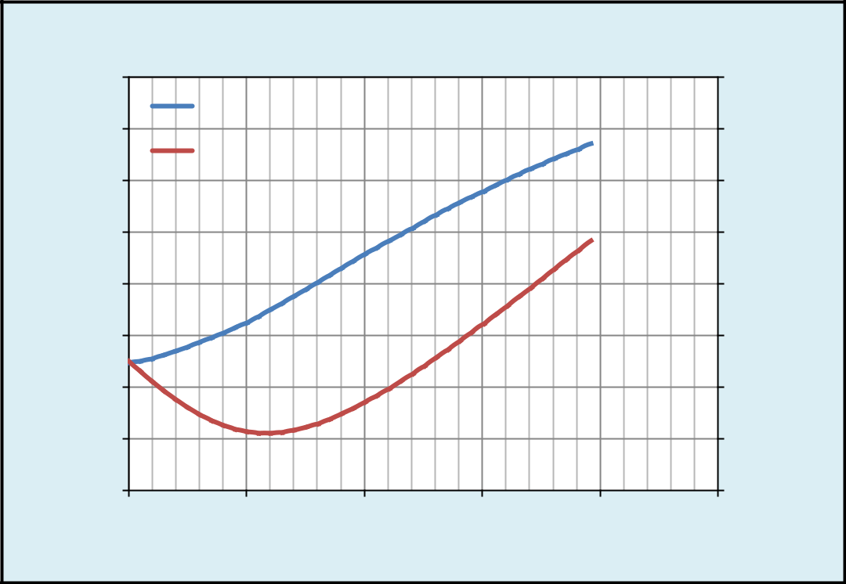

|  |
| --- |
| **Viscosity(cp)** |

0.040

0.035

0.030

0.025

0.020

0.015

0.010

0.005

0.000

0

**Z-factor & Viscosity vs Pressure**

|  |  |  |  |  |  |
| --- | --- | --- | --- | --- | --- |
|  |  |  |  | 1.550 |  |
| viscosity |  |  |  |  |  |
| z-factor |  |  |  | 1.450 |  |
|  |  |  |  |  |
|  |  |  |  | 1.350 |  |
|  |  |  |  | 1.250 |  |
|  |  |  |  | **z-factor** |  |
|  |  |  |  | 1.150 |  |
|  |  |  |  | 1.050 |  |
|  |  |  |  | 0.950 |  |
|  |  |  |  | 0.850 |  |
|  |  |  |  | 0.750 |  |
| 2000 | 4000 | 6000 | 8000 | 10000 |  |

**Pressure(psi)**

given pressure and temperature.

**Figure-19:** Z-factor and Viscosity vs Pressure plot

***4.1.2*** ***Estimation***

***Gas formation volume factor (Bg):*** The ratio of volume of gas at reservoir conditions to the volume of gas at standard conditions.

|  |  |  |  |  |  |
| --- | --- | --- | --- | --- | --- |
| Bg = | 0.005035∗ ∗ | | | Units: bbl/scf …….......…………………. Eq. (37) |  |
|  | |  |  |
|  |  |  | |  |  |
| Bg = | | 0.02827∗ ∗ |  | Units: ft³/scf ………….……………..… Eq. (38) |  |
|  | |  |
|  |  |  |  |



35

*A COMPREHENSIVE REVIEW OF NANO FLUID APPLICATION IN OIL RECOVERY*

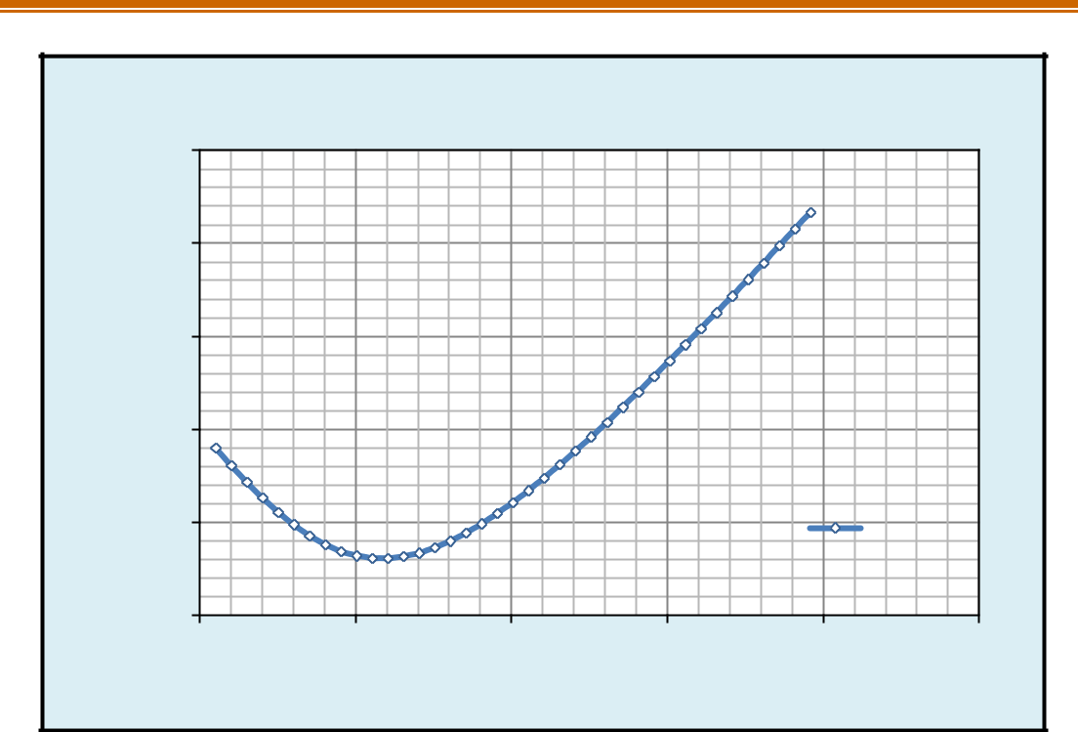

|  |  |  |  |  |  |  |  |
| --- | --- | --- | --- | --- | --- | --- | --- |
|  |  |  | **z-Factor vs Pressure** | |  |  |  |
|  | 1.300 |  |  |  |  |  |  |
|  | 1.200 |  |  |  |  |  |  |
| **z-factor** | 1.100 |  |  |  |  |  |  |
| 1.000 |  |  |  |  |  |  |
|  |  |  |  |  |  |  |
|  | 0.900 |  |  |  |  | z-factor |  |
|  | 0.800 |  |  |  |  |  |  |
|  | 0 | 2000 | 4000 | 6000 | 8000 | 10000 |  |
|  |  |  | **Pressure(psi)** | |  |  |  |

**Figure-20:** Z-factor vs Pressure plot

***Expansion factor (Eg):*** The reciprocal of gas formation volume factor gives the value of expansion factor (Eg).

|  |  |  |  |  |  |
| --- | --- | --- | --- | --- | --- |
| Eg= | 1 |  | Units: scf/bbl …….…..……………………………… Eq. (39) | |  |
|  | |  |
|  |  |  |  |
| Eg= | | | 35.37∗ | Units: scf/ft³ ………………………………………… Eq. (40) |  |
|  |  |
|  |  |  | ∗ | |  |



36

*A COMPREHENSIVE REVIEW OF NANO FLUID APPLICATION IN OIL RECOVERY*

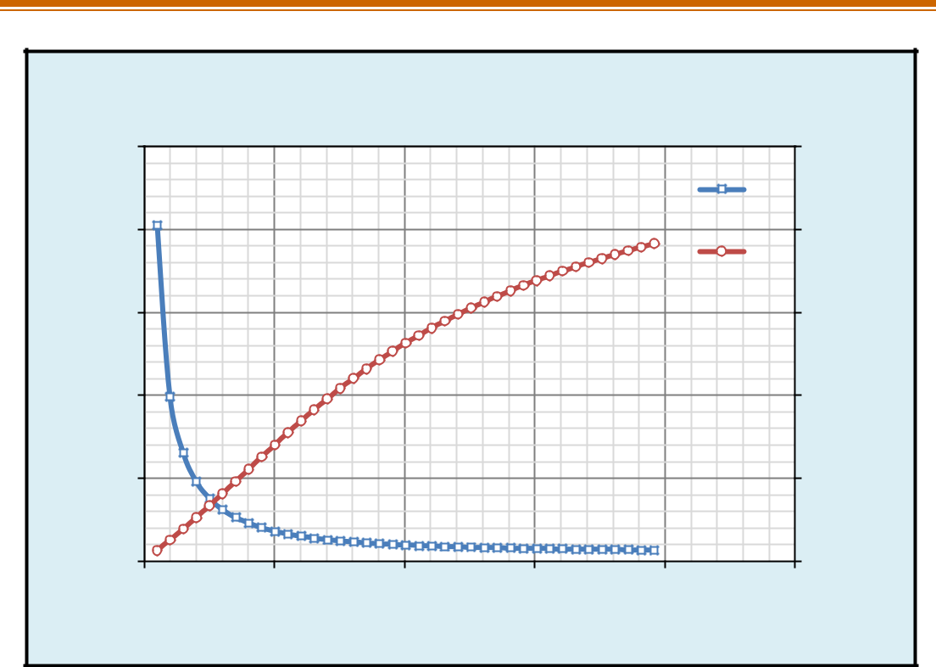

**Bg & Eg vs Pressure**

|  |
| --- |
| **Bg (bbl/scf)** |

0.020

0.016

0.012

0.008

0.004

0.000

0

|  |  |  |  |  |
| --- | --- | --- | --- | --- |
|  |  |  |  | 2500 |
|  |  |  |  | Bg |
|  |  |  |  | 2000 |
|  |  |  |  | Eg |
|  |  |  |  | 1500 |
|  |  |  |  | **Eg(scf/bbl)** |
|  |  |  |  | 1000 |
|  |  |  |  | 500 |
|  |  |  |  | 0 |
| 2000 | 4000 | 6000 | 8000 | 10000 |

**Pressure (psi)**

**Figure-21**: Bg& Eg vs Pressure plot

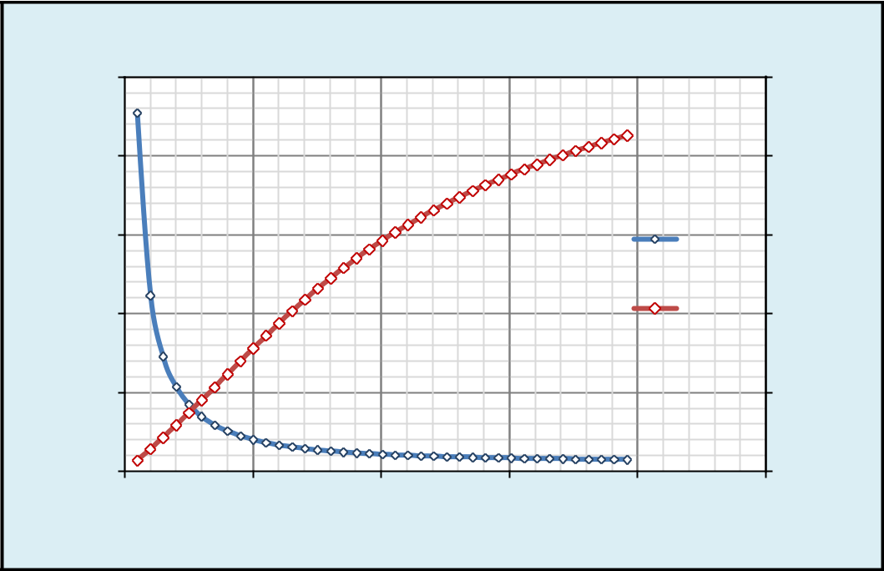

**Bg & Eg vs Pressure**

|  |  |  |  |  |  |  |  |  |
| --- | --- | --- | --- | --- | --- | --- | --- | --- |
|  | 0.10 |  |  |  |  | 400 |  |  |
|  | 0.08 |  |  |  |  | 320 |  |  |
| **Bg(ft3/scf)** | 0.06 |  |  |  | Bg | 240 | **Eg(scf/ft3)** |  |
| 0.04 |  |  |  | Eg | 160 |  |
|  |  |  |  |  |  |  |
|  | 0.02 |  |  |  |  | 80 |  |  |
|  | 0.00 |  |  |  |  | 0 |  |  |
|  | 0 | 2000 | 4000 | 6000 | 8000 | 10000 |  |  |
|  |  |  | **Pressure(psi)** | |  |  |  |  |
|  |  | **Figure-22:** Bg& Eg vs Pressure plot | | | |  |  |  |



37

*A COMPREHENSIVE REVIEW OF NANO FLUID APPLICATION IN OIL RECOVERY*



Bg is used to convert surface measured volumes to reservoir conditions, assuming the fluid is in a single gas phase despite temperature and pressure changes. It is normally used for estimating gas reserves.

***Result Summary: Case study-1***

As the pressure increases, initially the z-factor value decreases and increases gradually.

As the pressure increases, the formation volume factor (Bg) of the gas decreases.

As the pressure increases, the expansion factor (Eg) of the gas increases.

**4.2 Case Study-2: Estimation of Well Bore Storage Coefficient (Cs)**

***Well bore storage co-efficient:*** When a production well is shut in at well head, the flow into well bore at sand face continues after shut-in. It is known as well bore storage (Cs). It delays the beginning of middle time region and makes its recognition more difficult. Well bore storage can be reduced by using down hole shut-in tool.

In this case study, a 9000 feet well with a casing inner diameter of 7-5/8”, tubing inner diameter of 2” and outer diameter of 2-7/8” was taken, whose wellbore fluid density is 58lbm/ft3. The compressibility of the fluid is 1.5x10-5psi-1.

The well bore storage coefficients for a rising liquid/gas interface and fluid filled wellbore were calculated with the given data.

***4.2.1 Input data***

|  |  |
| --- | --- |
| Well Total depth | = 9000 feet |
| Casing Inner Diameter (ID) | = 7-5/8” |
| Tubing Outer Diameter (OD) | = 2 7/8” |
| Tubing Inner Diameter (OD) | = 2” |
| Well bore fluid density | = 58lbm/ft3 |
| Compressibility of the fluid | = 1.5x10-5 psi-1 |



38

0.894∗

*A COMPREHENSIVE REVIEW OF NANO FLUID APPLICATION IN OIL RECOVERY*

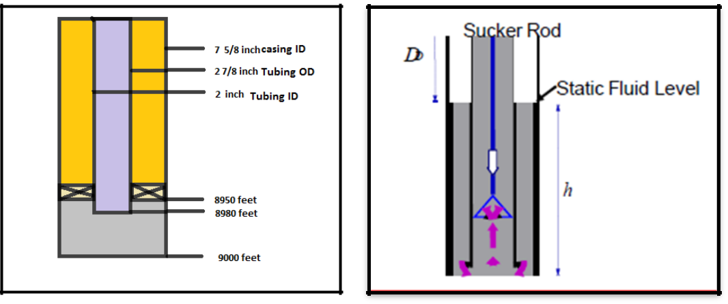

**Figure-23:** Fluid filled wellbore **Figure-24:** Rising liquid/gas interface

***4.2.2 Estimation***

Well bore storage constant is determined for a constant rate production. The casing ID and tubing OD are given in inches. They are converted to feet (dividing by 12)

Area of well bore (Awb) =0.271 ft²

Density of well bore fluid (ρwb) =58lbm/ft³

The value of Awb is substituted in the formula and well bore storage coefficient is obtained.

For a well with a rising liquid/ gas interface in the wellbore,

|  |  |  |  |
| --- | --- | --- | --- |
| = | ∗ ∗ | …..…………………………………….. Eq. (41) |  |
| . ∗ ∗ |  |
|  |  |  |

***Result:*** The value of well bore storage coefficient (Cs) is 0.119bbl/psi

The wellbore storage constant (Csd) is,

= ∅∗ ∗ℎ∗ 2 ………………………………………….. Eq. (42)



39

*A COMPREHENSIVE REVIEW OF NANO FLUID APPLICATION IN OIL RECOVERY*



|  |  |
| --- | --- |
| Porosity (ϕ) | = 0.25 |
| Total compressibility (Ct) | = 1.29x10ˉ5 psi-1 |
| Thickness (h) | = 100 feet |
| Well bore radius (feet) | = 0.354 feet |

Well bore storage constant (cs) = 0.119 bbl/psi

***Result:*** The dimensionless wellbore storage constant (Csd) is 2632 in the range of 103<Csd<104

Packer depth = 8950 feet

Tubing length = 8980 feet

Tubing Inner Diameter (ID) = 2”

The wellbore storage coefficient is,

= ∗ ……………………………………………………… Eq. (43)

Where,

Vwb= Volume of the well bore (ft³)

Cwb = Compressibility of wellbore fluid (psi-1)

Here, the volume of tubing, annular volume above packer and volume of well bore below the packer were calculated and their sum gives the total volume of the well bore.

|  |  |
| --- | --- |
| Volume of tubing (Volume-1) | = 195.813 ft3 |
| Annular volume of above packer (Volume-2) | = 6.33 ft3 |
| Volume of wellbore below packer (Volume-3) | = 3.69 ft3 |
| Total Volume of wellbore (Vwb) | = 205.833 ft3 |
| Compressibility of wellbore fluid (Cwb) | = 1.5x10-5psi-1 |

Volume is given in cubic feet, from cubit feet to barrel converted by dividing with 5.615.

***Result:*** Wellbore storage coefficient (Cs) is 0.003087ft3/psi (or) 0.000548bbl/psi



40

*A COMPREHENSIVE REVIEW OF NANO FLUID APPLICATION IN OIL RECOVERY*



***Result Summary: Case study-2***

– The calculated value of wellbore storage co-efficient for a rising gas/liquid interface is 0.119bbl/psi and dimensionless storage constant 2632

– The calculated value of wellbore storage co-efficient for a fluid filled wellbore is 0.003087ft3/psi or 0.000548bbl/psi

**4.3 Case Study-3: Pressure Drawdown Test**

Pressure drawdown tests includes recording of bottom-hole pressure during a period of flow at a constant producing rate.

In this case study, a vertical single-phase oil well with an initial reservoir pressure of 5000psia was considered. The production time was 100hours and the flow rate was 1500 STB/day.

A semi log plot of pressure *versus* time gives the slope from which permeability was estimated. Reservoir parameters-Permeability, productivity index, radius of investigation, Well bore parameters- effective well bore radius, Near Well bore parameters- skin, ΔPskin, were calculated and flow efficiency (FE) of the well was estimated.

***4.3.1 Input data***

|  |  |
| --- | --- |
| Initial reservoir pressure | = 5000 psi |
| Production time | = 100 hours |
| Flow rate | = 1500 STB/ day |
| Fluid type | = Single phase-oil |
| Well orientation | = Vertical |
| Formation thickness | = 100 feet |
| Average formation porosity | = 0.25 |
| Total compressibility | = 1.29*10ˉ5 psi-1 |
| Well radius | = 0.354 feet |
| Oil viscosity | = 0.489 Cp |
| Oil formation volume factor (Bo) | = 1.295 bbl/STB |
| Pressure (at 200 hrs) | = 4919.757 psi |



41

*A COMPREHENSIVE REVIEW OF NANO FLUID APPLICATION IN OIL RECOVERY*



***4.3.2 Analysis***

Pressure “P” (psi) plotted against producing time “tp” (hours) (tp converted to log (tp)) and slope m was derived from the equation in the Y= mx+c form,

= 162.6∗ ∗ ₒ∗µₒ ……………………………………………. Eq. (44)

∗ℎ

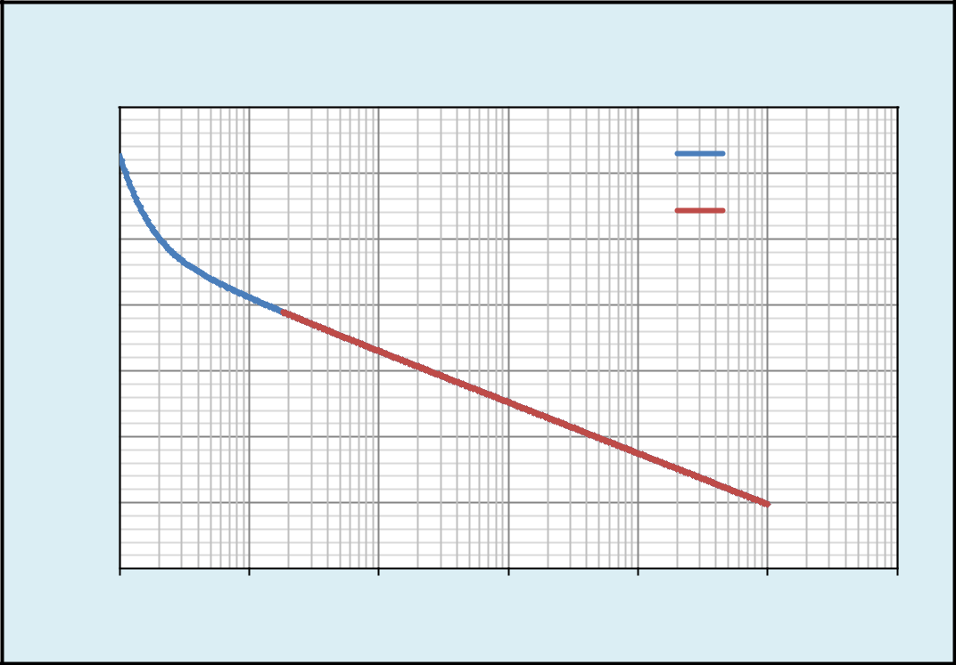

**Semi-Log Plot: Pressure Vs Production Time**

**(Pressure Drawdown)**

|  |
| --- |
| **Pressure(psia)** |

4980

4970

4960

4950

4940

4930

4920

4910

0.00

Drawdown

Slope

0.01 0.10 1.00 10.00 100.00 1000.00

**Production Time (tp)**

**Figure-25:** Pressure vs Production Time plot

***Result:*** Slope (m) of the pressure Drawdown is -7.768 psi/log-cycle.

After deriving the slope from the graph, permeability (k) was calculated as follows,

***Permeability:*** The ease with which a fluid flows in a porous medium is known as permeability, denoted by ‘k’.

= 162.6∗ ∗ ₒ∗µₒ……………………………………………………. Eq. (45)

∗ℎ

***Result:*** Permeability (k) for the given reservoir is 199.832 mD



42

*A COMPREHENSIVE REVIEW OF NANO FLUID APPLICATION IN OIL RECOVERY*



***Skin:*** Formation damage caused by drilling fluid invasion, production, or injection can lead to positive skin and affects fluid flow by reducing permeability.

|  |  |  |  |  |  |
| --- | --- | --- | --- | --- | --- |
| = 1.151 ( | i− 1ℎ | − log ( | k | ) + 3.23)………………………… Eq. (46) |  |
| m | ϕ∗µ∗Ct∗rw2 |  |
|  |  |  |  |

***Result:*** Skin factor (S) for the given problem is 3.008.

From the given data and derived Slope (m), Permeability (k) and Skin factor (S) were calculated.

***Effective wellbore radius (rwʹ):*** The value of well bore radius that produces equivalent results to those obtained using a skin factor of zero.

rwʹ = rw * eˉˢ ………………………………..………………………. Eq. (47)

***Result:*** Effective wellbore radius (rwʹ) is 0.0174 feet

***Radius of investigation (ri):*** Radius of investigation represents how far the pressure transient has travelled into the reservoir.

ri= 0.029 ∗ (√( ∗µ∗ )√( ∗ )) ……………………….……………………. Eq. (48)

***Result:*** Radius of the investigation (ri) is 3264.45 feet

***Skin pressure drop:*** It is one of the most important parameter used in production engineering as it could refer to a sick or excited well and leads to additional work-over operations. High ΔPskin (pressure drop due to skin) near wellbore creates additional pressure drop, changes fluid composition, changes streamline flow.

ΔPskin = 0.87*m*s ………………………………..………………. Eq. (49)

m =7.768 s=3.008

***Result:*** skin pressure drop ΔPskin = 20.22 psi

***Productivity Index:*** The ratio of *flow rate* to the *Pi-Pwf* is known as productivity index. It is denoted by ‘J’.



43

*A COMPREHENSIVE REVIEW OF NANO FLUID APPLICATION IN OIL RECOVERY*



|  |  |  |  |  |
| --- | --- | --- | --- | --- |
| J = [ |  | ] | Units: STB/day psiˉ¹ ……………………………………… Eq. (50) |  |
| − |  |
|  |  |  |  |

J = 18.518 STB/day psiˉ¹

***Ideal productivity index:*** It is defined as the productivity index with zero skin damage.

***Actual productivity index:*** It is defined as the ratio of flow rate to the difference of initial reservoir pressure and flowing bottom pressure, skin pressure drop.

***Flow Efficiency (FE):*** *The ratio of actual productivity index to ideal productivity index is known as flow efficiency.*

Flow Efficiency = (P*-Pwf –ΔPskin)/ (P*-Pwf) ……………………………… Eq. (51)

Flow Efficiency (FE) = 0.689

***Result Summary: Case study-3***

– In the drawdown test, the calculated values of reservoir parameters are

|  |  |  |
| --- | --- | --- |
|  | Permeability | = 199.832mD, |
|  | Skin | = 3.008 |
| effective well bore radius | | = 0.0174feet |
|  | radius of investigation | = 3264.45feet |
|  | skin pressure drop | = 20.22psi |
|  | flow efficiency | = 0.689 (68.9%) |

**4.4 Case Study-4: Pressure Buildup Test**

In pressure build up test, the well is first produced and then it is shut and well bore pressure is recorded with time.

In this case study, a vertical single phase oil well with a total time period of testing 500 hours and an initial reservoir pressure of 5000psia was considered. After producing the well for 100hours, it was shut-in for a period of 400 hours for a pressure buildup study.



44

*A COMPREHENSIVE REVIEW OF NANO FLUID APPLICATION IN OIL RECOVERY*



By Horner’s approximation the slope ‘m’ was calculated on a semi-log plot (pressure versus tp+Δt/Δt). Based on the ‘m’ value, permeability was calculated with the given data. Reservoir parameters such as skin, effective wellbore radius, radius of investigation, ΔPskin, productivity index (PI) were calculated and flow efficiency (FE) of the well was estimated.

***4.4.1 Input data***

|  |  |
| --- | --- |
| Time period | = 500 hours |
| Initial reservoir pressure | = 5000 psi |
| Production time | = 100 hours |
| Flow rate | = 1500 STB/day |
| Shut-in period (Δt) | = 400 hours |
| Pressure (at Δt=1hr) | = 4984.511 psi |
| Fluid type | = Single phase-oil |
| Well orientation | = Vertical |
| Formation thickness | = 100 feet |
| Average formation porosity | = 25% |
| Total compressibility | = 1.29*10-5 psi-1 |
| Well radius | = 0.354 feet |
| Oil Viscosity | = 0.489 Cp |
| Oil formation volume factor (Bo) | = 1.295 Rbbl/STB |
| ***4.4.2 Analysis*** |  |

Pressure plotted against the test time and the variation of pressure with time was observed.



45

*A COMPREHENSIVE REVIEW OF NANO FLUID APPLICATION IN OIL RECOVERY*

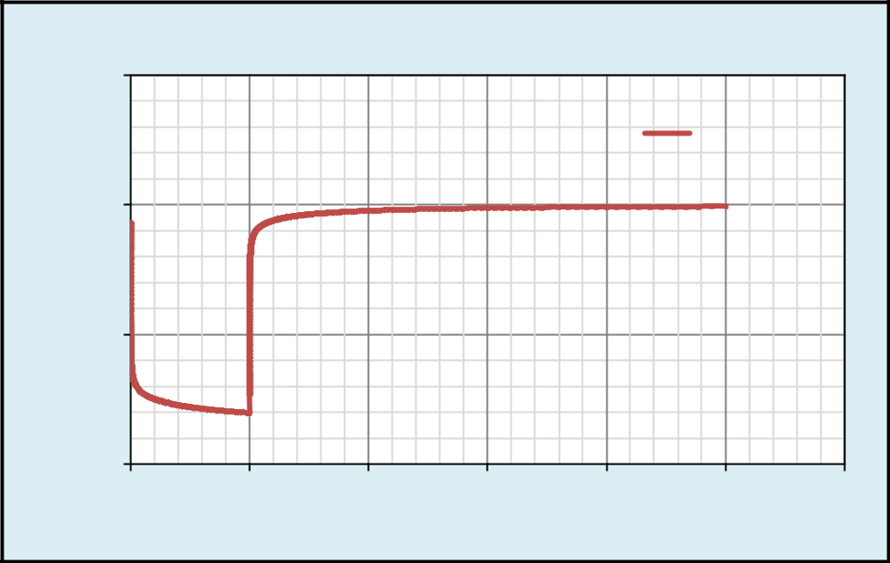

|  |
| --- |
| **Pressure (psia)** |

5050

5000

4950

4900

0

**Pressre vs Time (Drawdown+Buildup)**

DD+BUP

100 200 300 400 500 600

**Time (hours)**

**Figure-26:** Drawdown+ Buildup Test: Pressure vs Time plot

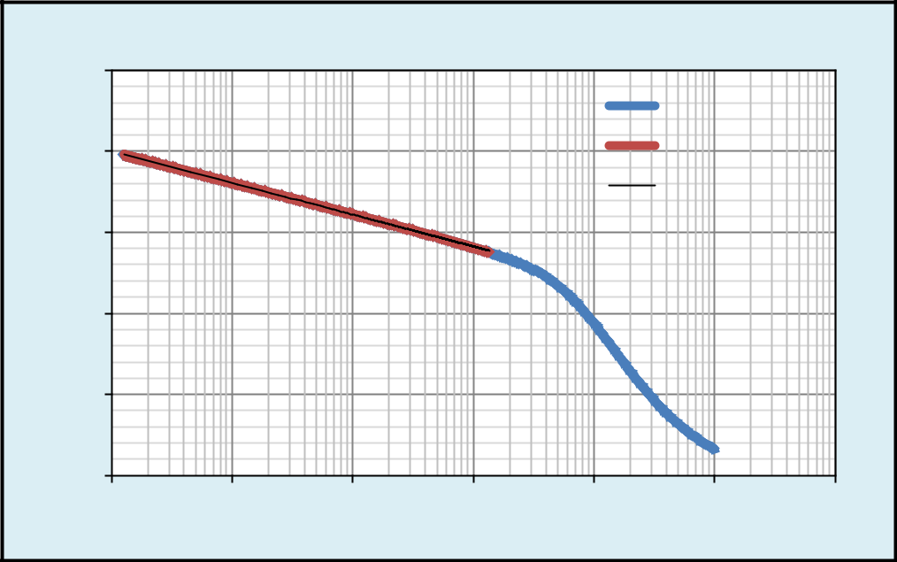

|  |
| --- |
| **Pressure (psi)** |

5020

5000

4980

4960

4940

4920

1

**Semi-Log Plot: Pressure vs (tp+Δt/Δt)**

Buildup Data

Slope

Log. (Slope)

10 100 1000 10000 100000 1000000

**(tp+Δt/Δt)**

**Figure-27:** Semi-Log plot: Pressure vs (tp+Δt/Δt)



46

*A COMPREHENSIVE REVIEW OF NANO FLUID APPLICATION IN OIL RECOVERY*



***Result:*** Slope (m) was 7.84 psi/log-cycle, which was calculated from the pressure vs (tp+Δt/Δt) plot.

***Permeability (k):*** The ease with which a fluid flows in a porous medium is known as permeability, denoted by ‘k’.

= 162.6∗ ∗ ₒ∗µₒ……..…………………….……………………. Eq. (52)

∗ℎ

***Result:*** Permeability (k) of the reservoir -197.186 mD

***Skin (S):*** Formation damage caused by drilling fluid invasion, production or injection can lead to positive skin, and effect fluid flow by reducing permeability.

|  |  |  |  |  |  |  |
| --- | --- | --- | --- | --- | --- | --- |
| = 1.151 ( | ₁hr− wf |  | − log ( | k | ) + 3.23) ……………………………. Eq. (53) |  |
| m | | ϕ∗µ∗Ct∗rw2 |  |
|  |  |  |  |

***Result:*** From the given data, derived slope (m) and permeability (k) from these two values calculated skin factor (S) = 3.

***Effective well bore radius (rwʹ):*** The value of well bore radius that produces equivalent results to those obtained using a skin factor of zero.

rwʹ= rw*eˉˢ …………………………………………………………….. Eq. (54)

***Result:*** - Effective wellbore radius (rw’) - 0.0173 feet

***Radius of investigation (ri):*** Radius of investigation represents how far the pressure transient has travelled into the reservoir.

ri= 0.029 ∗ (√( ∗µ∗ )√( ∗ )) ………………………….…………………. Eq. (55)

***Result:*** The radius of investigation (ri) - 6498.9 feet

***Skin pressure drop:*** High ΔPskin (pressure drop due to skin) near wellbore reduces the permeability, changes fluid composition, changes streamline flow.

ΔPskin = 20.462



47

*A COMPREHENSIVE REVIEW OF NANO FLUID APPLICATION IN OIL RECOVERY*



***Productivity index (J):*** The ratio of flow rate to the difference of initial reservoir pressure and flowing bottom hole pressure is known as productivity index. It is denoted by ‘J’.

J =  −  Units: STB/day psiˉ¹ …………………………………………… Eq. (56)

***Ideal productivity index (Ji):*** It is defined as the productivity index with zero skin damage.

Ji=23.172 STB/day psi-1

***Result:*** Ideal productivity index value - 23.172 STB/day-psi-1

***Actual productivity index (Ja):***It is defined as the ratio of flow rate to the difference of initial reservoir pressure and flowing bottom pressure, skin pressure drop.

Ja=18.518 STB/day psi-1

***Result:*** Actual productivity index value -18.518 STB/day-psi-1

***Flow Efficiency (FE):*** The ratio of actual productivity index to the ideal productivity index is known as flow efficiency.

FE = (Ja/Ji) ………………………………….………………………. Eq. (57)

***Result:*** Flow Efficiency of the reservoir -S 0.742

***Extrapolated pressure***: P*(Pi) can be obtained from the equation of the line y=mx+c

Y=-3.41ln(x) + 5000, if x=1 then

Y=5000 (Since Y = P*)

***Result:*** Extrapolated pressure P*=5000psia

***Result Summary: Case study-4***

– In the buildup test, the calculated reservoir parameters are

Permeability=197.16mD



48

*A COMPREHENSIVE REVIEW OF NANO FLUID APPLICATION IN OIL RECOVERY*



|  |  |  |
| --- | --- | --- |
|  | Skin | = 3 |
| Effective well bore radius | | = 0.0173feet |
|  | Radius of investigation | = 6498.9feet |
|  | Skin pressure drop | =20.462feet |
|  | Flow efficiency | = 0.742 |
|  | Extrapolated pressure P* | =5000psi |

**4.5 Case Study-5: Estimation of Gas Well Deliverability**

***Gas well deliverability*** indicates the rate at which a gas well can produce at a given bottom hole or wellhead pressure. The productivity of a gas well is determined by deliverability tests (flow after flow, isochronal and modified isochronal test).

In the present case study, a gas well of initial reservoir pressure 5000psi and initial flow rate of 6 MMSCF/day was considered. The total time period was 200hours.The absolute open flow potential (AOF) was calculated by flow after flow test: 1.Empirical method (C& n method) 2.Theoretical method (LIT method).

In flow after flow, the well was produced at a series of different stabilized flow rates in increasing order and measuring the bottom hole flowing pressure at the sand face.

|  |  |
| --- | --- |
| ***4.5.1 Input data*** |  |
| Time period | = 200 hours |
| Initial reservoir pressure | = 5000 psia |

Flowing bottom hole pressures and flow rates are as follows:

**Table-2:** Flow rates and flowing bottom hole pressure

|  |  |
| --- | --- |
| **Flowing bottom hole** | **Flow rate, qg** |
| **pressure, pwf (psi)** | **(MMscf/day)** |
|  |  |
| 4955.70 | 2 |
| 4909.99 | 4 |
| 4851.07 | 6 |
| 4785.56 | 8 |
| 4642.79 | 12 |
|  |  |



49

*A COMPREHENSIVE REVIEW OF NANO FLUID APPLICATION IN OIL RECOVERY*



***4.5.2*** ***Analysis***

***Absolute open flow potential:*** The absolute open flow (AOF) potential of a well is the rate at which the well would produce against zero sand face back pressure. It is calculated by Empirical method (C &n method) and Theoretical method (LIT method)

1. ***Empirical method ( C and n method)***

qg=CΔP2=(Pr2-Pwf2)n…………………………………………………..….. Eq. (58)

In this method, plots of well bore pressure *versus* time and gas flow rate were made.

The value of Pwf2 was calculated.

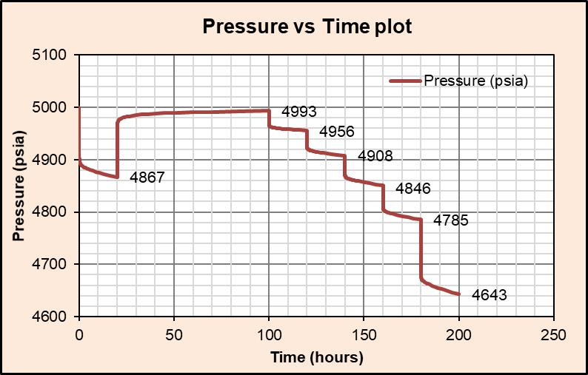

**Figure-28:** Pressure vs Time plot



50

*A COMPREHENSIVE REVIEW OF NANO FLUID APPLICATION IN OIL RECOVERY*

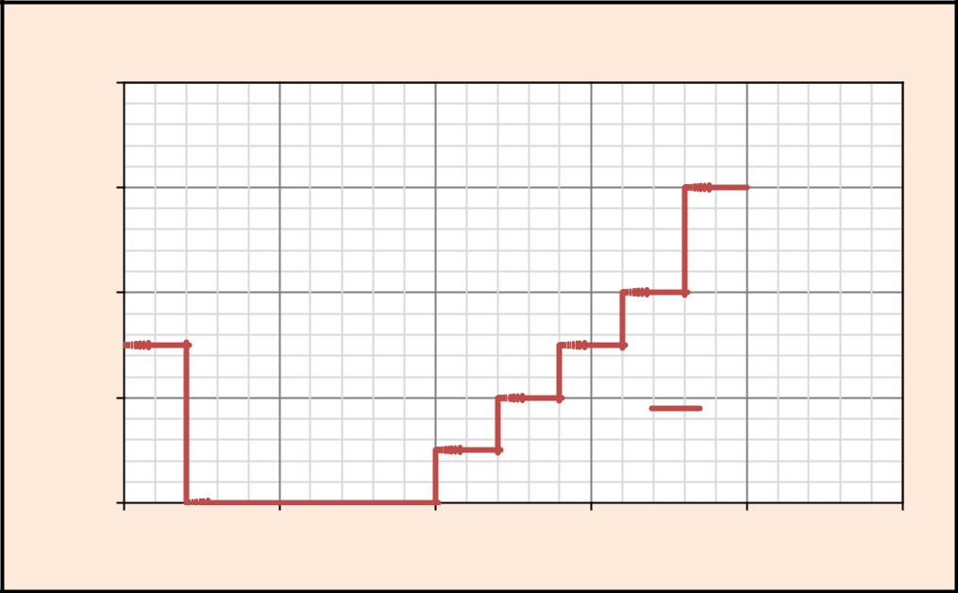

|  |
| --- |
| **Flow rate (MMscf/day)** |

16

12

8

4

0

0

**Flow rate vs Time plot**

Flow rate

(MMscf/day)

50 100 150 200 250

**Time (hours)**

**Figure-29:** Flow rate vs Time plot

The values of log (qg), Pwf2, ΔP2, log (ΔP2) values were calculated and tabulated. **Table-3**: Δp² and log (Δp²) values

|  |  |  |  |  |  |  |  |
| --- | --- | --- | --- | --- | --- | --- | --- |
|  | **TIME** | **qg** | **Log** | **Pwf2** | **ΔP2** | **Log** |  |
|  | **(hours)** | **(MMscf/day)** | **(qg)** | **(ΔP2)** |  |
|  |  |  |  |
|  | 120 | 2 | 1.301 | 24558962 | 373383 | 5.572 |  |
|  | 140 | 4 | 0.602 | 24108002 | 824344 | 5.916 |  |
|  | 160 | 6 | 0.778 | 23532880 | 1399466 | 6.145 |  |
|  | 180 | 8 | 0.903 | 22901585 | 2098415 | 6.321 |  |
|  | 200 | 12 | 1.079 | 21555499 | 3376847 | 6.528 |  |
|  |  |  |  | 216 | 24932130 | 7.396 |  |
|  |  |  |  |  |  |  |  |

To calculate the value of n, plot between Pr²-Pwf² vs qg is taken. The slope obtained is 1/n. the reciprocal of 1/n gives n value.

|  |  |  |  |  |  |  |  |  |  |  |  |
| --- | --- | --- | --- | --- | --- | --- | --- | --- | --- | --- | --- |
| **C=** |  |  |  | ……………………….………………………………… Eq. (59) | | | | | | |  |
|  |  |  |  |
|  |  |  |  |
|  | ( − )ⁿ | | | |  |  |  |  |  |  |  |
|  |  |  |  |  |  |  |  | ) |  | |  |
| **1/n=** | | ( | − | | ) | − ( | − |  | ……………………………………… Eq. (60) |  |
|  | ( )− ( ) | | | | |  |  |  |
|  |  |  |  |  |  |  |
|  |  |  |  |  |  |  |  |  | 51 | |  |



*A COMPREHENSIVE REVIEW OF NANO FLUID APPLICATION IN OIL RECOVERY*



**Table-4:** n, C and AOF values

|  |  |  |  |  |  |
| --- | --- | --- | --- | --- | --- |
| **q** | **1/n** | **n** | **C** | **AOF** |  |
| **(MMscf/day)** |  |
|  |  |  |  |  |
|  |  |  |  |  |  |
| 4 | 1.142 | 0.870 | 0.0000645 | 60.61 |  |
| 6 | 1.250 | 0.800 | 0.0000630 | 60.00 |  |
| 8 | 1.360 | 0.735 | 0.0000605 | 59.70 |  |
| 12 | 1.170 | 0.850 | 0.0000618 | 59.41 |  |

***Result:***

The values of C & n were calculated by using the Eq. (59) & Eq. (60) were 0.000063 and 0.8 respectively.

By C and n method the average AOF was 60.00MMscf/day

1. ***Theoretical method(LIT method):***

Pr2-Pwf2=Aqg+Bqg2…………………………………… Eq. (61)

qAOF =(-A+SQRT(A2+4BΔPmax2)/2B………….…………….. Eq. (62)

**Table-5**: a, b and AOF values



|  |  |  |  |  |  |  |  |  |
| --- | --- | --- | --- | --- | --- | --- | --- | --- |
|  | **qg** | **(P2-pwf2)/qg** | **b** | **a** | **-a** | **2b** | **(a2-4bc) AOF** | |
|  |  |  |  |  |  |  |  |  |
|  | 4 | 216086.00 | 9697.00 | 167296.0 | -167296.0 | 19394.0 | 981366.8 | 42.77 |
|  | 6 | 233250.30 | 13579.00 | 151770.0 | -151770.0 | 27158.0 | 1140716.0 | 36.41 |
|  | 8 | 260000.90 | 14528.00 | 146072.0 | -146072.0 | 29056.0 | 1162833.0 | 35.00 |
|  | 12 | 281403.90 | 4775.50 | 224097.0 | -224097.0 | 9551.0 | 679685.9 | 47.70 |
|  |  |  |  |  |  |  |  |  |

***Result:*** By using LIT method the AOF was 42.77MMscf/day



52

*A COMPREHENSIVE REVIEW OF NANO FLUID APPLICATION IN OIL RECOVERY*

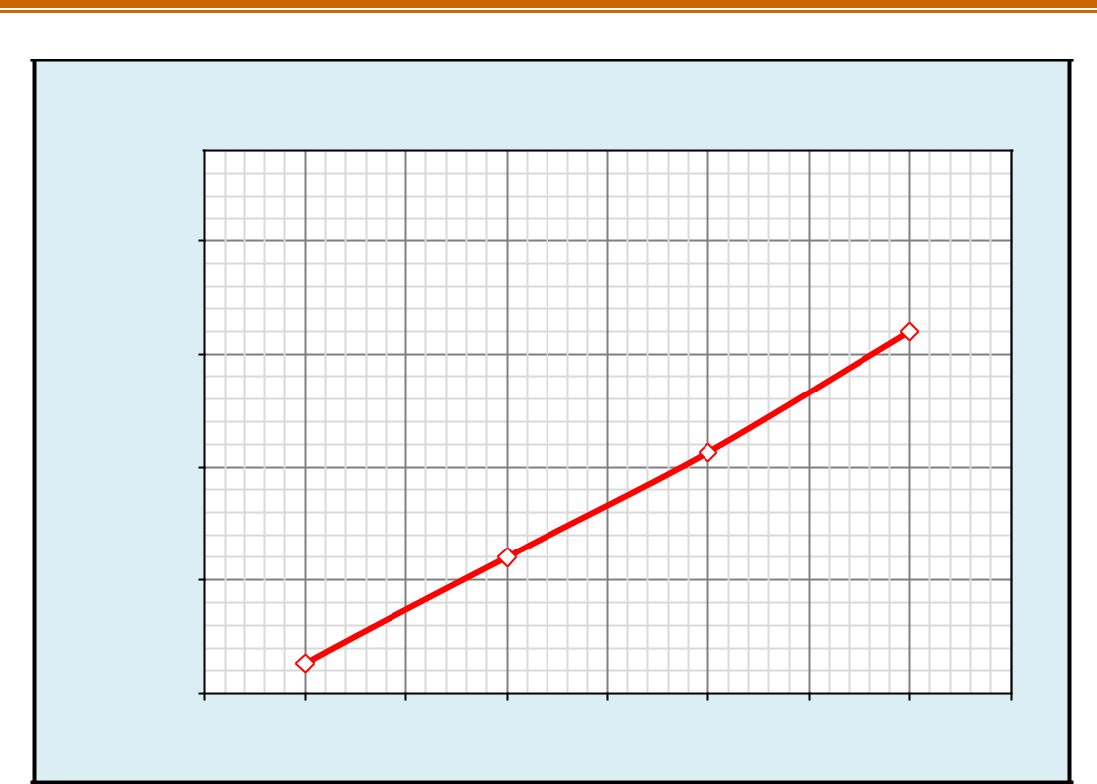

**Pr2-Pwf2/qg vs qg Plot**

|  |
| --- |
| **Pr2-Pwf2/qg** |

280000

255000

230000

205000

180000

1

 slope b

2 3 4 5 6 7 8 9

**Flow rate (qg)**

**Figure-30:** Pr2-Pwf2/qg versus qg plot

***Result Summary: Case study-5***

By empirical method (c and n method) the calculated value of AOF was 60MMscf/day

By Theoretical method (LIT method) the value of AOF was 42.77MMscf/day



53

*A COMPREHENSIVE REVIEW OF NANO FLUID APPLICATION IN OIL RECOVERY*



***CHAPTER – 5:***

***RESULTS***



54

*A COMPREHENSIVE REVIEW OF NANO FLUID APPLICATION IN OIL RECOVERY*



***5.1 Results summary***

***Case Study-1:*** The values of gas formation volume factor and expansion factor are calculated for the corresponding p, z values. The data plotted in graph and trend are as shown,

– As the pressure increases, initially the z-factor value decreases and increases gradually.

– As the pressure increases, the formation volume factor (Bg) of the gas decreases.

– As the pressure increases, the expansion factor (Eg) of the gas increases.

***Case Study-2*:** The calculated value of wellbore storage co-efficient for a rising gas/liquid interface was 0.119bbl/psi and dimensionless wellbore storage constant 2632.

– The calculated value of wellbore storage co-efficient for a fluid filled wellbore was 0.003087ft3/psi or 0.000548bbl/psi

***Case Study-3:*** In a pressure drawdown test, the reservoir parameters were,

|  |  |  |
| --- | --- | --- |
| – | Permeability | =199.832mD, |
| – | Skin | =3.008 |
| – effective well bore radius | | =0.0174feet |
| – | radius of investigation | =3264.45feet |
| – | skin pressure drop | =20.22psi |
| – | flow efficiency | =0.689 |
| – | extrapolated pressure | =4935psia |

***CaseStudy-4:*** In the buildup test calculated reservoir parameters were

|  |  |  |
| --- | --- | --- |
| – | Permeability | =197.16mD |
| – | Skin | = 3 |
| – Effective well bore radius | | = 0.0173feet |
| – | Radius of investigation | = 6498.9feet |
| – | Skin pressure drop | =20.46psi |
| – | Flow efficiency | = 0.742 |
| – | Extrapolated pressure | =5000psi |



55

*A COMPREHENSIVE REVIEW OF NANO FLUID APPLICATION IN OIL RECOVERY*



***Case Study-5*:** Absolute open flow potential of a gas well was calculated by c and n method, the estimated AOF value was 60.00MMscf/day, by LIT method, the calculated AOF value was 42.77MMscf/day.



56

*A COMPREHENSIVE REVIEW OF NANO FLUID APPLICATION IN OIL RECOVERY*



***References***

***Papers:***

Abdus Satter, Ghulam M Iqbal, in Reservoir engineering- 2016

***Text books:***

John lee, well testing, society of petroleum engineers of AIME, New York 1982.

Dake, L.P.: Fundamentals of reservoir engineering, Elsevier scientific publishing Co., Amsterdam (1978)

Craft, B.C and Hawkins, M.F. Jr.: Applied petroleum reservoir engineering, Prentice-Hall Book Co., Inc., Englewood Cliffs, NJ (1959)

Horner, D.R.; “Pressure buildup in wells” proc., Third world pet cong., The Hague (1951)

Dake, L.P., The practice of reservoir engineering, Amsterdam: Elsevier, 1994

Van Everdingen, A.F., “The skin effect and its influence on the productive capacity of a well”, Trans AIME 1953,

Amanat U. Chaudhary. “Oil well testing handbook”.2004

***Websites:***

<https://www.testwells.com/oil-and-gas-deliverability-test/>

<https://www.sciencedirect.com/well-testing/>

<https://www.glossary.oilfield.slb.com/drawdown-test/>

[https://petrowiki.org-Well_test/](https://petrowiki.org-well_test/)

<https://academic.oup.com-interference-well-testing/>

<https://www.chem.fsu.edu-gas-laws/>



57

*A COMPREHENSIVE REVIEW OF NANO FLUID APPLICATION IN OIL RECOVERY*



***Nomenclature***

|  |  |  |  |
| --- | --- | --- | --- |
| ***Symbol*** | ***Term*** | ***Unit*** |  |
|  |  |  |  |
| Pi | initial reservoir pressure | psia |  |
| Pwf | flowing bottom hole pressure | psia |  |
| qₒ | flow rate of oil | STB/day |  |
| µₒ | viscosity of oil | Cp |  |
| Bₒ | formation volume factor of oil | bbl/STB |  |
| h | thickness of formation | feet |  |
| ϕ | porosity | % |  |
| Ct | total compressibility | psiˉ¹ |  |
| rw | well bore radius | feet |  |
| s | skin factor | - |  |
| k | permeability | mD |  |
| m | slope | psi/log-cycle |  |
| tp | production time | hours |  |
| Pws | shut-in bottom hole pressure | psia |  |
| γ | specific gravity | - |  |
| Ρg | density of gas | lb/ft³ |  |
| Ρa | density of air | lb/ft³ |  |
| Z | compressibility factor | - |  |
| Va | actual volume | ft³ |  |
| Vi | ideal volume | ft³ |  |
| Bg | gas formation volume factor | bbl/scf,ft³/scf |  |
| qg | flow rate of gas | MMscf/day |  |
| ri | radius of investigation | feet |  |
| rwʹ | effective well bore radius | feet |  |
|  |  |
| Cs | well bore storage constant | bbl/psi |  |
| Cwb | compressibility of wellbore fluid | psiˉ¹ |  |
| Vwb | volume of well bore | ft³ |  |
| Ji | ideal productivity index | STB/psi-day |  |
| Ja | actual productivity index | STB/psi-day |  |
| FE | flow efficiency | - |  |
|  |  |  |  |



58